

Abaqus-SwiftComp GUI 1.0
USER’S MANUAL

June 1st, 2016

Bo Peng, Su Tian, Lingxuan Zhou & Wenbin Yu




TABLE OF CONTENTS

Page #

1.0 GENERAL INFORMATION 1-1
1.1 Installation and Get Started 1-1
1.2 Abaqus-SwiftComp GUI General Guide 1-2
1.2.1 SG preparation 1-2
1.2.2 MSG analysis 1-6
1.2.3 Visualization button 1-8
1.2.4 Limitations of the current version 1-8
2.0 CREATE COMMON MODEL 2-1
2.1 Laminate (1D SG) 2-1
2.1.1 1D SG preparation 2-1
2.1.2 Homogenization 2-11
2.1.3 Dehomogenization 2-15
2.2 Square Pack Microstructure (2D SG) 2-18
2.2.1 2D SG preparation 2-18
2.2.2 Homogenization 2-20
2.2.3 Dehomogenization 2-22
2.3 Spherical Inclusion Microstructure with Interphase (3D SG) 2-24
2.3.1 3D SG preparation 2-24
2.3.2 Homogenization 2-25
2.3.3 Dehomogenization 2-27
2.4 Summary 2-29
3.0 CREATE USER-DEFINED MODEL 3-1
3.1 Square Pack Microstructure (2D SG) 3-1
Step 1: Create materials 3-1
Step 2: Set work plane 3-1
Step 3: Create geometry of 2D customized SG 3-2
Step 4: Assign material sections, create mesh for the 2D customized SG 3-2
3.2 Arbitrary Shape Inclusions Microstructure (2D SG) 3-5
Step 1: Create materials and sections 3-5
Step 2: Set work plane 3-6
Step 3: Create geometry of 2D customized SG 3-6
Step 4: Assign material sections, create mesh for the 2D customized SG 3-7
Step 5: Generate User-defined Model Mesh 3-7
Step 6: Homogenization and dehomogenization 3-9
3.3 Create Layups 3-12
3.3.1 Fast generation 3-12
3.3.2 Read from file 3-12
3.4 Cross-Section with Arbitrary Shape 3-14
3.4.1 Laminate in the GUI 3-14
3.4.2 Dialog box 3-14
3.4.3 Prerequisite 3-15
3.4.4 Example 3-15
3.5 Cross-Section with Airfoil Shape 3-28
3.5.1 General 3-28
3.5.2 Input data files 3-28
3.5.3 Create cross-section model in Abaqus from input files 3-32
3.5.4 Homogenization 3-33
4.0 IMPORT HOMOGENIZED PROPERTIES TO MACRO MODEL ANALYSIS 4-35

1.0 GENERAL INFORMATION

GENERAL INFORMATION

Based on the recently invented Mechanics of Structure Genome (MSG), SwiftComp™ provides an efficient and accurate approach for modeling composite materials and structures. It can be used either independently as a tool for virtual testing of composites or as a plugin to power conventional FEA codes with high-fidelity multiscale modeling for composites. SwiftComp™ implements a true multiscale theory which assures the best models at a given level of efficiency to capture both anisotropy and heterogeneity of composites at the microscopic scale or any other scale of user’s interest. SwiftComp™ enables engineers to model composites as a black aluminum, capturing details as needed and affordable. This saves orders of magnitude in computing time and resources without sacrificing accuracy, while enabling engineers to tackle complex problems effectively.

SwiftComp™ can be used as a standalone code or as a plugin for other commercial codes. To facilitate the use of SwiftComp™, a simple graphic user interface (GUI) with a toolbar integrated the functions of SwiftComp™ is developed in Abaqus. This manual focuses on explaining how to use Abaqus-SwiftComp GUI.

Chapter One introduces the installation of Abaqus-SwiftComp GUI, and provides a general guide for modeling and visualization in Abaqus-SwiftComp GUI. The guidance in Chapter One is brief, more details are included in the rest of chapters by examples.

Chapter Two describes how to quickly build common SGs and carry out homogenization and dehomogenization using SwiftComp™. Common SG can be built through a few steps, which will be a good start to get familiar with Abaqus-SwiftComp GUI.

Chapter Three introduces how to create user customized SGs through examples of general laminate (a common 1D SG), Square Pack Microstructure (a common 2D SG), 2D SGs for cross-sections with arbitrary shape, and 2D SGs for cross-section with airfoil shape. These two examples should give users a good preparation to build user-defined models according to different analysis needs.

1.1 Installation and Get Started

To get started to use Abaqus-SwiftComp GUI on your local machine, you just need to simply unzip the distribution package into a folder of your own choice, then in this folder, click the short cut file Abaqus-SwiftComp GUI to launch to Abaqus-SwiftComp GUI. Of course, you also need to have Abaqus and SwiftComp™ already installed on your computer. To install SwiftComp™ you should request the code from AnalySwift and follow the instruction inside the SwiftComp™ release package for installation.
After launched Abaqus-SwiftComp GUI, please set the Abaqus work directory (File->Set Work Directory) to be the work directory of your own choice. Please note that all the files generated will be stored in the work directory and the valid SwiftComp license requested from AnalySwift should also be stored in your work directory.

1.2 Abaqus-SwiftComp GUI General Guide

The only difference compared with the original Abaqus GUI is the added toolbar group as shown in Fig.1.2-1. The toolbar group composes of gadget buttons (1, 2), SG creation tool buttons (3, 4, 5, 6, 7, 8), SwiftComp™ analysis and visualization tool buttons (9, 10, 11, 12). Their functions can be simply described as follows:
- Work plane: set sketch plane for 1D/2D customized SGs.
- New layups: add new layups for 1D/2D SGs.
- 1D SG: create 1D SG, including common SGs and customized SGs.
- 2D common SG: create 2D common SGs.
- Assign layups: create laminate for 2D cross-sections.
- Erase layups: delete laminate for 2D cross-sections.
- Read file: create 2D cross-section from input data file.
- 3D common SG: create 3D common SGs.
- Homogenization: carry out homogenization analysis.
- Macro model: import the homogenized properties.
- Dehomogenization: carry out dehomogenization analysis.
- Visualization: visualize the results with only SwiftComp analysis files.

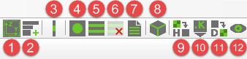
Fig. 1.2-1 The added toolbar group in Abaqus-SwiftComp GUI.

1.2.1 SG preparation
SG creation tool buttons (3-8) can help the user to set up the configurations of SGs.
Abaqus functions are highly integrated in building the SGs, such as materials, composite layup, section assignment, mesh etc. But some settings in the original Abaqus GUI are not used, and the meanings of some parameters are different, which needs special attentions from the user. The details will be explained in the following sections. For convenience, the term ‘Abaqus GUI’ is referred in this manual when using the functions of the original Abaqus, otherwise ‘Abaqus-SwiftComp GUI’ is explicitly specified. Italic texts represents the terms shown in dialog box of Abaqus GUI, and texts in ‘ ’ represents terms shown in dialog box of Abaqus-SwiftComp GUI.

Geometry
Users can create common SGs using the 1D SG button (3), 2D SG button (4), or 3D SG button (8), which provides common microstructures of composites for 1D, 2D and 3D SGs respectively. Or they can build customized 2D SGs using button 5, 6, 7 or Abaqus functions.
According to the convention of SwiftCompTM, for 1D SGs, the geometry should be aligned with Z direction in the global coordinate system; for 2D SGs, the geometry should be in the Y-Z plane in the global coordinate system. The work plane button help the user set up the work plane for customized 1D SGs and 2D SGs.
For 1D customized SG, the work plane button also creates a temporary line geometry in Z direction, and a set named ‘Set_Layup’. Then the user can use Create Composite Layup tool button of Abaqus GUI to create composite layup, in which Region is assigned using the set ‘Set_Layup’. The next step to create a 1D customized SG is to choose the ‘Composite Layup’ method in dialog box of the 1D SG button. After this step, the temporary line geometry will be deleted, and the actual 1D SG composed of consecutive line segments is created, of which each line segment represents a ply.
To create the geometry for a 2D customized SG, the next step is to use Create Shell: Planar button. Other procedures are the same as creating a 3D shell part in Abaqus GUI.
The procedure to create 3D customized SG geometry is the same as that to create a 3D part in Abaqus GUI.

Material
In the Material module, the elastic materials properties can be defined by types: Isotropic, Engineering Constants, Orthotropic and Anisotropic. If effective density of SG is required, density of the material should be specified; if thermoelastic analysis is conducted, Expansion and Specific Heat should be specified. If density, expansion and specific heat are required in the analysis but not specified, Abaqus-SwiftComp GUI will not ask for it, but use the default values, information will be shown in the message area. All the material properties can only be defined in the most basic way, advanced options such as temperature-dependent data, discrete fields cannot be used in the current version. Just like in Abaqus GUI, materials not used in SGs are allowed to exist.
Materials can also be imported from a file, whose format is XML. For more details, please go to section 3.3.2.

Sections
In Abaqus-SwiftComp GUI, section types Solid-Homogeneous, Shell-Homogeneous, Solid-Composite, Shell-Composite are applied. Sections are defined in the same way as in Abaqus GUI. Material sections not assigned to SGs are allowed to exist. Note: For 2D SGs, the geometry should be in the Y-Z plane in the global coordinate system. Abaqus only allow shell feature in 3D space to be placed in the Y-Z plane, thus practically, user can only use Shell-Homogeneous sections.

Section Assignment
Material section assignment is defined in the same way as in Abaqus GUI. Section assignments are allowed to be depressed, and the depressed sections assignment will be ignored.

Composite Layup
Composite Layup of Conventional Shell of Abaqus GUI is used in creating composite layup for 1D SGs and 2D SGs. Plies are allowed to be depressed or be edited using the tools in the dialog box. However the current version of Abaqus-SwiftComp GUI sometimes will crash when the user revises an existing composite layup or changes the part name of a 1D SG part, so it is highly recommended to save your work before the revision.
For 1D SG, information of the Index of the plies (not the Ply Name), Material, Thickness, Rotation Angle and Offset setting of this dialog box will be read into the input file (*.sc) of SwiftCompTM when doing homogenization. Region should be the set ‘Set_Layup’ which contains the whole 1D SG geometry. The same as that in Abaqus, the laminate is stacked from index ‘1’ to the maximum ply index. Things need to know also include:
1) The layup orientation can only be defined based on the Part global coordinate system.
2) Different from what defined in Abaqus, Thickness in the table is the actual thickness of each ply.
3) If Plate/Shell analysis is conducted, the first 4 option of Offset tab book can be used to shift the coordinate in the input file of SwiftComp™, which have the same definition as that of Abaqus. The shift will not show on the geometry of the SG. This will be further explained in Section 2.1.1 and Section 3.1.1.
4) Only one Composite layup is allowed to exist in a 1D SG part.

Layup file format
Composite Layup information can also be imported into Abaqus-SwiftComp GUI by choosing layup file (*.dat) with specific format. Currently this format is only valid for 1D SG. An example of the format is shown in Fig.1.2.1.
The file is composed of 3 parts.
In the first part (in the red frame) it is the layup control parameters.
The second part (in the blue frame) contains the information of each ply from bottom to top, which arranged in the sequence of: ply thickness (integer/float), ply angle (integer/float), material ID (integer).
The third part (in the green frame) provide the corresponding relationship between the material ID and the material name. The material with names shown in this part must be defined previously.
In details, in the first part, the first integer ‘4’ is the number of layers written in the second part, which is not necessarily the actual total number of the laminate). The second integer ‘2’ is the number of material types written in the third part. The character ‘s’ in the third place means ‘symmetric’, therefore the current layup angle is [45/30/60/-45]s. This character can also be ‘a’ which means ‘antisymmetric’, if in the current example it is changed to ‘a’, the layup angle will be [45/30/60/-45/60/30/45]. The last float ‘0.005’ is the offset ratio, which is explained in Section 2.1.1.
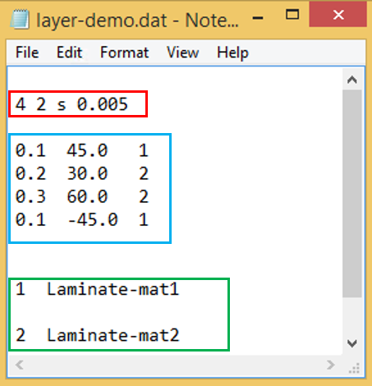
Fig. 1.2.1 layup file format example
Other notes:
- The character in the third place to denote ‘symmetric/antisymmetric’ can also be any string beginning with ‘s’ or ‘S’ for symmetric laminate (for example ‘sym’), or any string beginning with ‘a’ or ‘A’ for antisymmetric laminate (for example ‘Antisym’). If the laminate is not symmetric or antisymmetric, any other string can be inputed in the third place of the first row.
- If no offset is necessary, the float in the fourth place is not needed.
A layup can also be imported from a XML file. The ‘New layups’ function will read the material file and layup file and create one or more Solid-Composite sections. For more details, please go to section 3.3.2.

Orientation Assignment
User can use Abaqus’s own function to assign local element orientation. For 2D cross-section (shell feature in 3D space), there are several things user need to pay attention to. First, no matter what choices user makes for local axes numbering, the two axes shown at last will always be labeled 1 and 2. However, different choices may cause unexpected pointing directions of the two axes. Hence we need to set a rule here: following the convention of local coordinates used in SwiftComp, if a series of elemental coordinates changes along a curve C, the axis 1 in Abaqus will be the axis y2 in SwiftComp and tangent to C, and the axis 2 in Abaqus will be the axis y3 in SwiftComp and perpendicular to C. Second, it doesn’t matter for axis 2 pointing inward or outward, as long as it keeps consistency with the global coordinate and fiber orientation defined by user, since the fiber orientation will change if the direction of axis 2 (y3) changes.
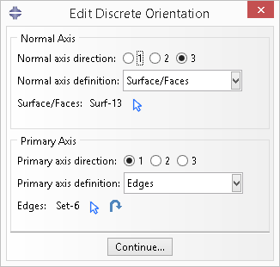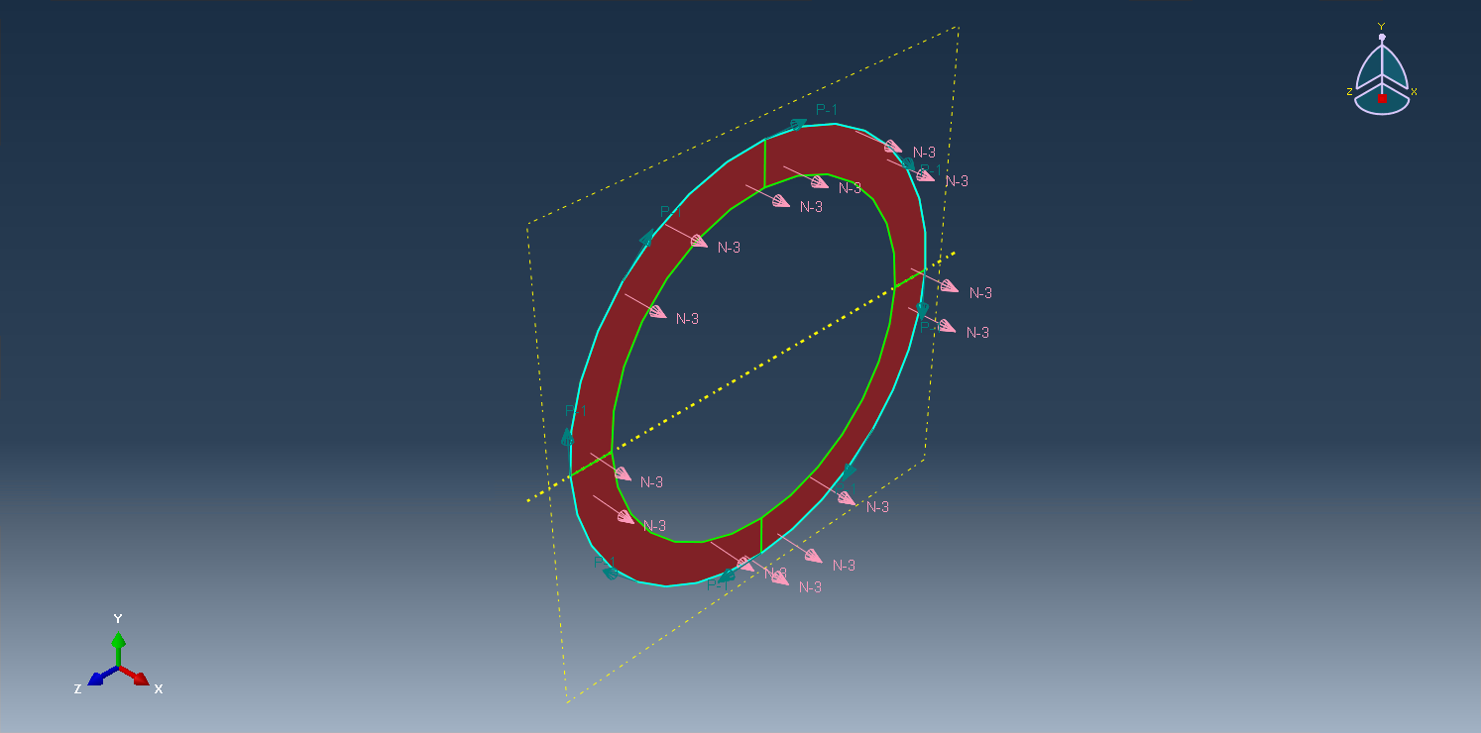
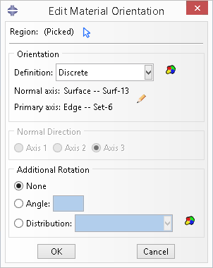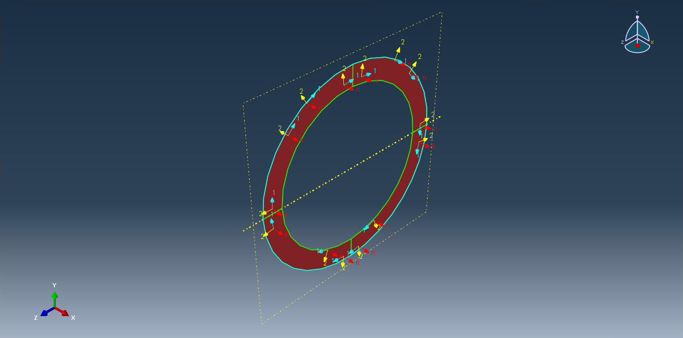

Mesh
Mesh must be generated on Part instead of on Instance. For 2D customized SGs, element types assigned in Abaqus GUI can be triangular (TRI) and quadrangular (QUAD), linear or quadratic such as S3, STRI3, S4, S4R, S8R, S8R5, etc. For 3D customize SGs, element types assigned in Abaqus GUI can be hexagonal (Hex) and tetrahedral (Tet), linear or quadratic such as C3D4, C3D10M, C3D8R, C3D8, C3D20R, C3D20 etc. However, only the nodal coordinates and element connectivities are read into SwiftCompTM for analysis, therefore the results are the same whether C3D4 or C3D4R is used.
For 1D SGs, mesh will be done automatically by using the 1D SG button. The element type assigned in GUI is B31, but just as shown in the dialog box of the 1D SG button, the actual element type used in the SG can be two-noded, three-noded, four-noded or five-noded. Each edge in the geometry of 1D SG represents 1 ply and has only 1 element in SwiftCompTM. Two-noded elements will be accurate for 3D solid, but five-noded elements are recommended for 2D Plate/Shell.
Special attention needs to be paid on generating periodic mesh. For periodic materials or heterogeneous materials with local periodicity, SwiftCompTM requires a mesh with periodic nodes on the edges to rigorously satisfy the periodicity requirement. Theoretically speaking, a node on the boundary surface must have a corresponding node on the parallel boundary surface with the same coordinates except the coordinate component normal to the boundary surface. However, currently this can only be guaranteed by the user. However, for complex microstructures, if it is difficult to create corresponding nodes on the periodic edges, SwiftCompTM provides a way to automatically provide the best approximate solution.

1.2.2 MSG analysis
SwiftCompTM analysis tool buttons include Homogenization button, Macro model button and Dehomogenization button.

Homogenization
Users can invoke SwiftComp™ to compute the effective properties for different structural models (beam, plate/shell or 3D solid). Please refer to SwiftComp™ manual for the meaning of the parameters. In the ‘Dimensionally Reducible Structures’ group box, only the ‘Classical’ in the specific model is supported in the current version. In the ‘Options’ group box, only ‘Elastic’ and ‘Thermoelastic’ analysis types are supported, the other options should be kept as default. Note 1D SG cannot be used for beam model.
The Abaqus-SwiftComp GUI can generate the SwiftComp input file (*.sc) from a CAE model or an Abaqus input file. The user can check the box before ‘New SwiftComp file name’ to specify the SwiftComp input file name, such as ‘Layup2s’, which will generate a file ‘Layup2s.sc’. If the file name is not specified, the default file name will be in the form of:
partName_nSG#_macroModelDimension_elementType.sc.
For 1D SG, the elementType is in the form of ‘n#’, where ‘#’ is the number of nodes in each element of the SG. For 2D and 3D SG, the elementType is the element type name of the first element in the model, using the term in Abaqus.
The GUI can determine ‘Omega’ (the volume of SG in the macro model) by itself in simple cases as follows:
- When the SG part has geometry information, and is a line, rectangle or cube.
- When the SG part has no geometry information, and is a line, rectangle or cube (voids can be in the SG). In this case, when the SG has a huge a number of nodes, specifying ‘Omega’ by the user will speedup the preparation of the model needed for homogenization.
After the homogenization of SwiftComp™, the effective properties will pop up automatically. In some situations that error may occur, the user can check the command line window and it should report the error message of running SwiftComp™, which gives your indication what is wrong with the model.

Macro model: Import the homogenized properties
The effective properties obtained from homogenization can be used in macro model analysis. Using this button can help user import the effective properties into a newly created model with the name of the SwiftComp input file. In the current version of Abaqus-SwiftComp GUI, effective properties of 1D macroscopic model (beam) will not be imported into Abaqus, since no beam element in Abaqus can take a fully populated stiffness matrix. Thus user need to choose other methods to carry out the macroscopic model analysis for beams. More details are explained in Section 4.0.

Dehomogenization
To conduct dehomogenization analysis, users must provide the homogenization files (*.sc, *.sc.k, *.sc.opt) of the SG and the global behavior parameters. The homogenization files must be in the current work directory. There are 2 two methods to provide the homogenizations files. The details are explained in Section 2.1.3.
User must specify the global behavior parameters. Please refer to SwiftComp™ manual for the meaning of each the global behavior parameter in this dialog box. With provided global behavior, users can invoke SwiftComp™ to compute the local fields including displacements, stresses and strains and other possible fields of interests, depending on the analysis. The information will then be used to create an odb file with the same name as the SwiftComp™ input file, so that the user can use the functions in the Visualization module of Abaqus GUI for postprocessing of the results. The post-processing results are automatically loaded, but the users need to change to the Visualization model by themselves. Contour plots are available for all local fields including three displacement components (U1, U2, U3) and its magnitude, six nodal strain components (EN11, EN22, EN33, 2EN23, 2EN13, 2EN12) and the derived quantities such as Mises strain, six nodal stress components (SN11, SN22, SN33, SN23, SN13, SN12), and other possible fields of interest, depending on the analysis and the derived quantities such as Mises stress.
In the current version, the odb file contains no information of geometry and material properties and geometry, although sections are kept. Under the *.odb trunk of the Output Database tree, sections can be found, and each section contains the elements with the same material properties. For 1D SGs, each section contains elements with the same material properties and the same layer angle.

1.2.3 Visualization button

Visualization
Users can use the Visualization tool button to create an *.odb file with the dehomogenization result files of SwiftComp™ (*.sc.u, *.sc.sn), and view the contour plots of the local fields including displacements, stresses and strains. Therefore it is not necessary to always save the *.cae file and *.odb file of the SG. Different material sections can be viewed, but the material properties cannot be reached in the *.odb file.

1.2.4 Limitations of the current version
As stated previously, the current version of the Abaqus-SwiftComp GUI has the following limitations:
- Change part name and edit the composite layup of 1D SG may cause unexpected crash, therefore save your work frequently is highly recommended.
- When a lot of work is done in the same session of Abaqus, sometimes in the command line window it shows: cannot find Notepad or SwiftComp, or the input line is too long. The user just need to close the current session of Abaqus and also close the command window, then restart the command window and the GUI.

2.0 CREATE COMMON MODEL

CREATE COMMON MODEL

Abaqus-SwiftComp GUI provides a convenient way to create some common SG models. Engineers can easily create the geometry of these models, and invoke SwiftComp™ to perform homogenization and dehomogenization for different composites with common SGs.
Currently, Abaqus-SwiftComp GUI provides the following common SG models:
1D SG: laminate.

2D SG: square pack microstructure with or without interphase region, hexagonal pack microstructure with or without interphase region.

3D SG: spherical inclusion microstructure with or without interphase region.

In this chapter, we will use some common SGs for different models (e.g. solid, plate/shell and beam) to illustrate how to use Abaqus-SwiftComp GUI to perform homogenization and dehomogenization.

2.1 Laminate (1D SG)

2.1.1 1D SG preparation
1D SG is simple compared with 2D/3D SG, which allows the GUI save most of the work for the user. This section will introduce 4 methods developed for generating 1D SG respectively. The four methods are: Fast Generate, Composite Layup, Composite Sections, Read from file. Fast Generate function only applies to laminates with constant layer thickness and single material property, while the other 3 methods can apply to general laminates.
Note users must pay attention to the general remarks illustrated in Section 1.2.1 Composite Layup.
The buttons for creating 1D SG are shown in the Fig. 2.1.1.
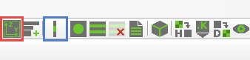
Fig. 2.1-1 work plane button (in the red frame) and 1D SG button (in the blue frame)

Method 1: Fast Generate
To create a 1D common SG quickly, Fast Generate function can be applied. Fast Generate function only applies to laminates with constant layer thickness and single material property.

Step 1: Create materials
The first step is to create a material in Abaqus GUI. The material ‘material-1’ used in this example has the properties as shown in Table 2.1-1.

Step 2: Create geometry and mesh of 1D SG
Then the user can click the 1D SG button in the blue frame shown in Fig. 2.1-1. In the dialog box popped out in Fig. 2.1-2, choose ‘Fast Generate’, and input the required information: layup, ply thickness, offset ratio, choose model and material which has been created, and element type. Layups can be specified following the tips provided in the dialog box. The meaning of the offset ratio is illustrated in Fig. 2.1-3. The number after bracket means the repeating times and “s” means symmetry.

Table 2.1-1 Material properties
Material | E₁  GPa | E₂  GPa | E₃  GPa | ₁₂ | ₁₃ | ₂₃ | G₁₂  GPa | G₁₃  GPa | G₂₃  GPa
Material-1 | 117.0 | 8.54 | 8.54 | 0.278 | 0.278 | 0.5 | 3.9 | 3.9 | 2.83

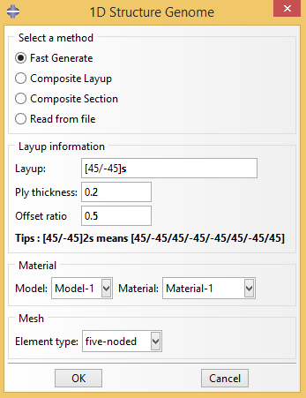
Fig. 2.1-2 Create 1D SG dialog box
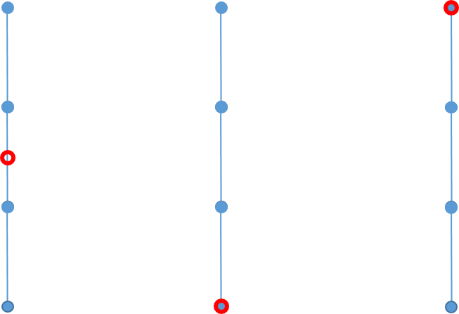
- Offset = 0 (b) Offset = -0.5 (c) Offset = +0.5

Fig. 2.1-3 The coordinate origin of the coordinate system in the generated SwiftComp input file (*.sc) by specifying Offset ratio, where the red hollow circle represents the coordinate origin.
Using the information provided in this dialog box, a 1D SG part named as ‘Laminate’ is created. The layup and offset ratio information are stored in the Composite Layup as shown in Fig. 2.1-4. The offset ratio will not be shown in the geometry of the part ‘Laminate’, but only be saved in the Offset tab book in the dialog box and later be used in generating the input file of SwiftComp™. In other words, Abaqus Composite Layup manager can be used to double check whether the inputs for Fast Generate are correctly provided and interpreted.
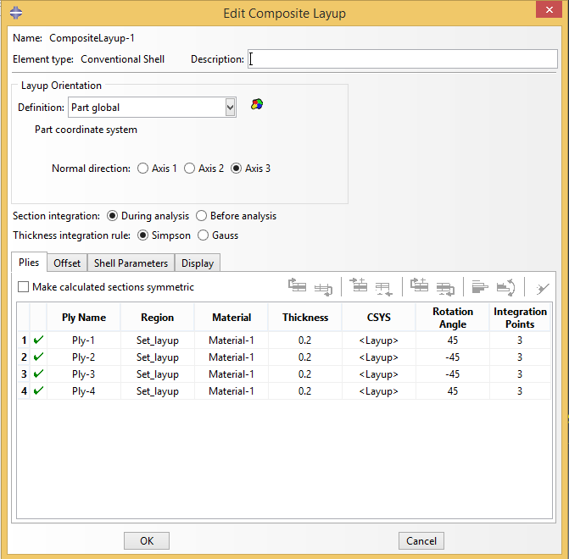
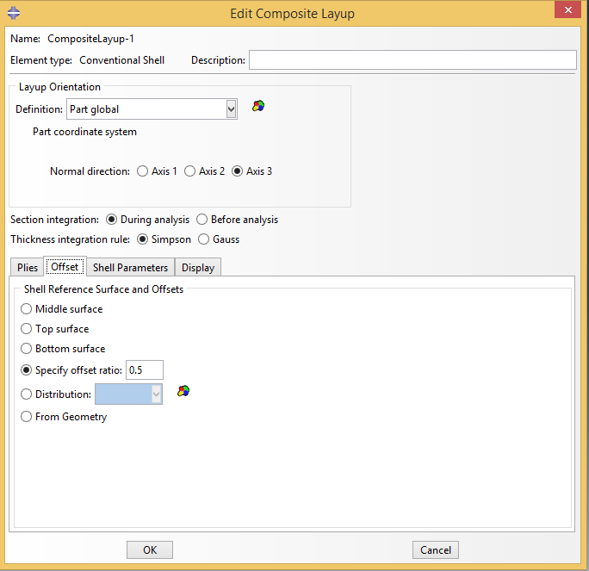
Fig. 2.1-4 Composite Layup contain the layup and offset ratio information.

For laminates, the mesh has been generated right after defining laminate. As stated in Section 1.2.1-> Mesh, the element type chosen in Abaqus is B31 with 2 nodes in each element. In this example, we create a 1D SG containing 4 plies ([45/-45]s laminate), which require 4 elements in SwiftComp. Each five-noded element in SwiftComp is composed of 4 B31 element in Abaqus, therefore the 1D SG has 16 B31 elements in all as shown in Fig. 2.1-5. Note it is not an approximation but a technique to trick Abaqus to generate 5-noded elements for SwiftComp, which is particularly needed if the macroscopic structural model is a plate/shell model.
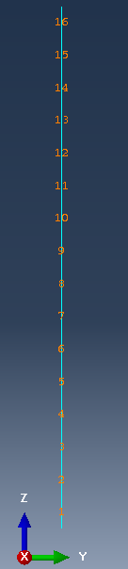
Fig. 2.1-5 16 B31 elements are generated for a 4 ply 1D SG with five-noded element type in SwiftComp.

Method 2: Composite Layup
This method takes advantage of the Composite Layup function of Abaqus GUI, which allows ply thickness and material properties to be different in each ply.

Step 1: Create materials
To create a customized 1D SG, the first step is to create the materials in Abaqus GUI. In this example, we use the material properties shown in Table 3.1.
Table 2.1-1 Material properties
Material name | E₁  GPa | E₂  GPa | E₃  GPa | ₁₂ | ₁₃ | ₂₃ | G₁₂  GPa | G₁₃  GPa | G₂₃  GPa
Laminate-mat1 | 250.0 | 50.0 | 50.0 | 0.25 | 0.25 | 0.25 | 2.0 | 2.0 | 5.0
Laminate-mat2 | 200.0 | 20.0 | 20.0 | 0.3 | 0.3 | 0.3 | 2.0 | 2.0 | 5.0

Step 2: Set work plane
As stated in section 1.2.1 Geometry, 1D SG must align with Z axis. This is achieved by the work plane button (in the red frame in Fig. 2.1-1). Click the work plane button, the dialog box in Fig. 2.1-6 pops out, then choose the model and give the part name for the 1D SG part, choose the SG dimension to be 1D. The work plane button will create a datum plane and a datum axis in the part. The work plane button also creates a temporary line geometry in Z direction, and a set named ‘Set_Layup’ as shown in Fig. 2.1-7.

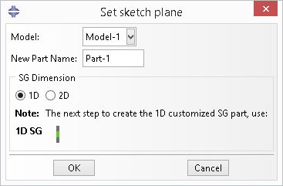
Fig. 2.1-6 work plane button dialog box

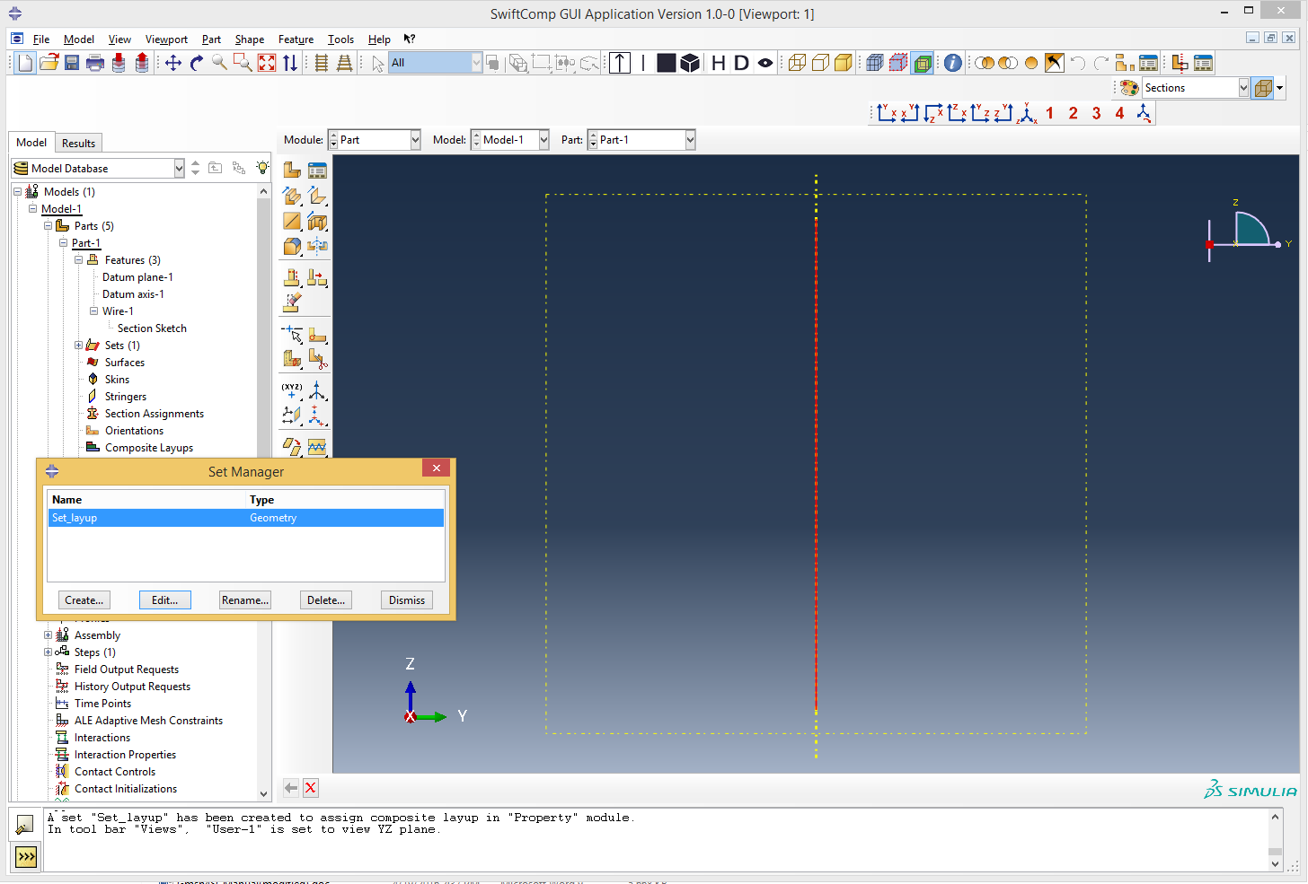
Fig. 2.1-7 After use the work plane button

Step 3: Create Composite Layup
Then the user can use Create Composite Layup tool in the Property module to create composite layup and assign Region using the set ‘Set_Layup’ as shown in Fig. 2.1-8 and Fig. 2.1-9. The first 4 options of the ‘Offset’ tab book can be used to specify offset of the coordinate origin in the *.sc file. In this example, the default offset ratio (0.0) is kept. The parameter ‘Offset’ has the same meaning of ‘Offset ratio’ as explained in Section 2.1.
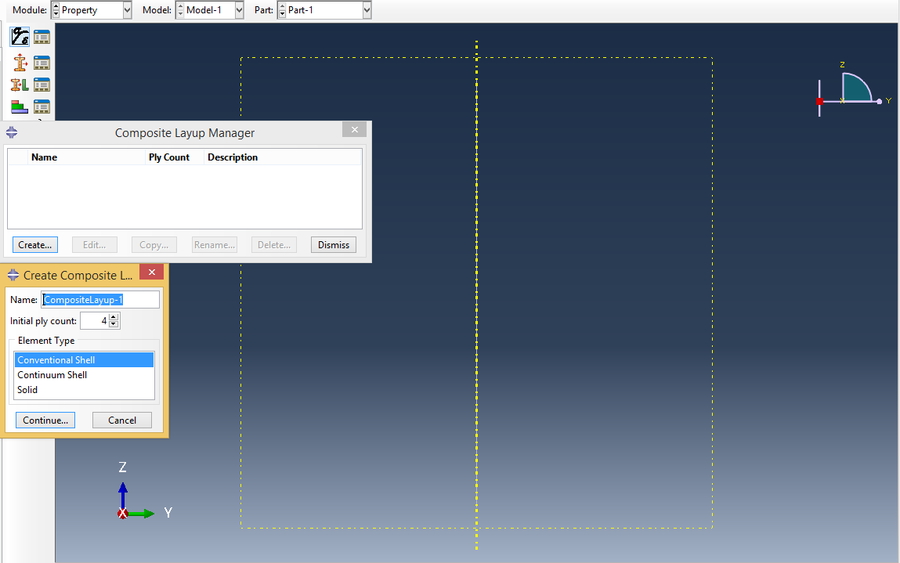
Fig. 2.1-8 Create composite layup

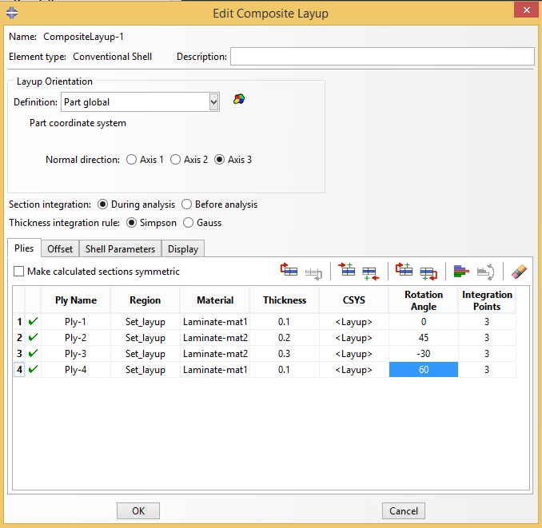
Fig. 2.1-9 Configure the composite layup

Step 4: Create geometry and mesh of 1D SG
The next step to create a 1D customized SG is to choose the ‘Composite Layup’ method in dialog box of the 1D SG button (Fig. 2.1-10). After this step, the temporary line geometry will be deleted, and the actual 1D SG composed of consecutive edges is created, of which each edge represents a ply.
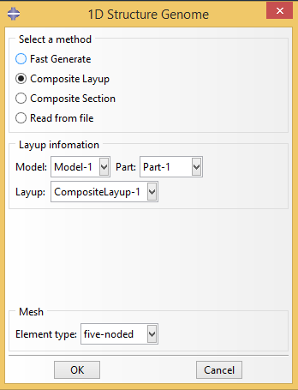
Fig. 2.1-10 Use Composite Layup method to create general 1D SG
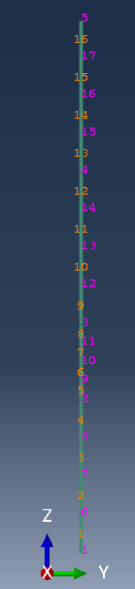
Fig. 2.1-11 The 1D SG created (numbers in orange are element numbers)

After Step 4, the 1D SG has been built. The user can check the element number in the Mesh module as shown in Fig. 2.1-11. Similar to the 1D SG generated by fast generated method, each edge represents an element in SG, which contains 4 B31 elements. Therefore there are 16 B31 elements in the model. The created part can be used for homogenization and dehomogenization analysis. Clearly the ‘Fast Generate’ method does the same thing as what does in ‘Composite Layup’ method for simple laminate cases.

Method 3: Composite sections
This method take advantage of the Sections-> Composite sections function of Abaqus GUI, which allows ply thickness and material properties to be different in each ply.

Step 1: Create materials and Composite sections
To use this method, first the user need to create mateirals and composite sections in the model, as shown in Fig. 2.1-12. The Element Relative Thickness is the actual ply thickness. Symmetric layers, Layup name and Ply Name in the dialog box are ignored in creating 1D SG.

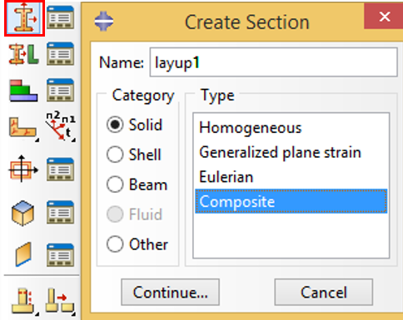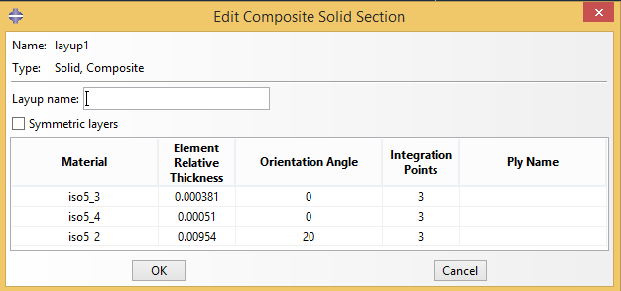
Fig. 2.1-12 Create Composite Sections

Users can use function ‘New layups’ to create Solid-Composite sections, as explained in Section 3.3.

Step 2: : Create geometry and mesh of 1D SG
The next step to create a 1D customized SG is to choose the ‘Composite Section’ method in dialog box of the 1D SG button (Fig. 2.1-13) and input the required parameters. The parameter ‘Offset’ has the same meaning of ‘Offset ratio’ as explained in Section 2.1.
Click OK, the 1D SG will be created. An Composite Layup containing the information from the Composite Section will also be created. In Homogenization, the information of the 1D SG will be read from the Composite Layup instead of the Composite Section. Therefore multiple Composite Sections are allowed to exist, but only 1 Composite Layup is allowed to exist in a SG.
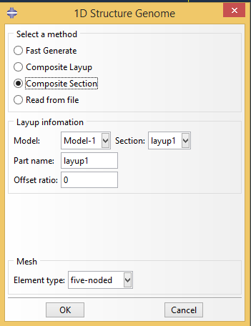
Fig. 2.1-13 Use Composite Section method to create general 1D SG

Method 4: Read from file
This method also allows ply thickness and material properties to be different in each ply. The information except material properties will be read from a *.dat file.
In this example, we use the file showin in Fig. 2.1.14.

Step 1: Create materials
To use this method, first the user need to create mateirals in the model. Here we use the material properties in Table 2.1.

Step 2: Prepare layup input file
In this example we prepare a file as shown in Fig. 2.1-14. The format has explained in the Section 1.2.1 Layup file format.
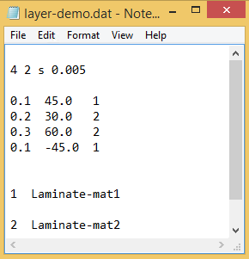
Fig. 2.1-14 layup input file (*.dat)

Step 3: Create geometry and mesh of 1D SG
Choose this file in the dialog box: 1D Structure Genome as shown in Fig. 2.1-15.
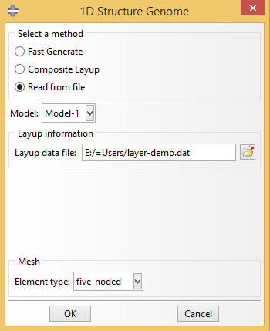
Fig. 2.1-15 The 1D SG created (numbers in orange are element numbers)

Then the 1D SG will be created, of which the composite layup information can be checked in the Composite Layup Dialog box as shown in the Fig.2.1-16.
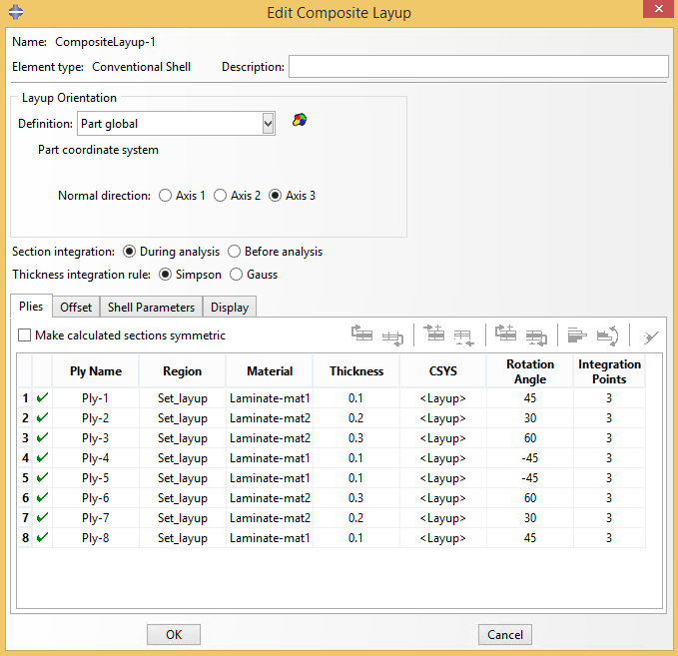
Fig. 2.1-16 The composite layup of the1D SG created

2.1.2 Homogenization
We will use the model generated by fast generate to show the results of Homogenization and Dehomogenization.
Click the homogenization button in the red frame of Fig. 2.1-17, a dialog box in Fig. 2.1-18 will pop up.
In this example, if we choose 3D (solid) for the macro model dimension, then the default file name will be Laminate_nSG1_3D_n5.sc, where 3D stands for 3D solid model.

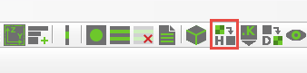
Fig. 2.1-17 Homogenization button
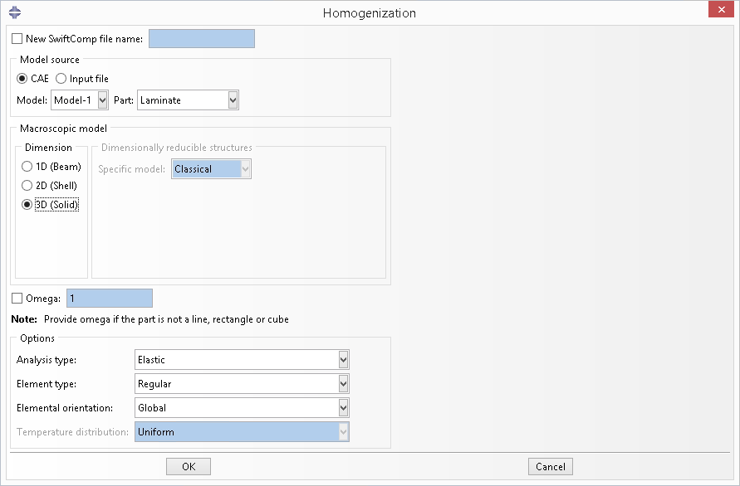
Fig. 2.1-18 Homogenization dialog box for 3D solid model

Click OK and wait for preparing the input file of SwiftComp™ and homogenization.
After the computation of SwiftComp™, the effective properties will pop up automatically (Fig. 2.1-19).
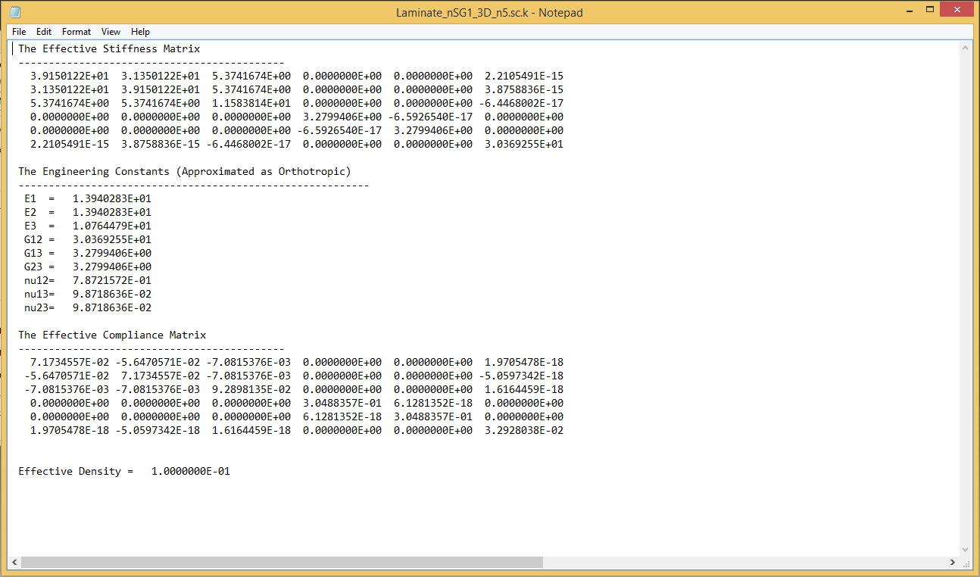
Fig. 2.1-19 Effective properties of 3D solid model
In the homogenization, the basic information of the SG model as shown in Fig. 2.1-20 have been saved into sg model, which can be accessed by python script using the path ‘mdb.customData.sgs[sg_name]’, where ‘sg_name’ is the SwiftComp file name in homogenization.
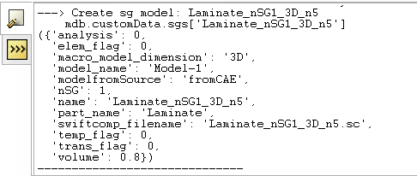
Fig. 2.1-20 sg model data created after homogenization

If we choose plate/shell model (Fig. 2.1-21), the default file name will be Laminate_nSG1_2D_n5.sc where 2D stands for a plate/shell model (2D). After homogenization, the ABD matrix of the homogenized plate/shell will be obtained (Fig. 2.1-22). The offset ratio will influence the results of plate/shell model as it effectively sets the reference surface at different locations. Note 1D SG cannot be used for beam model.

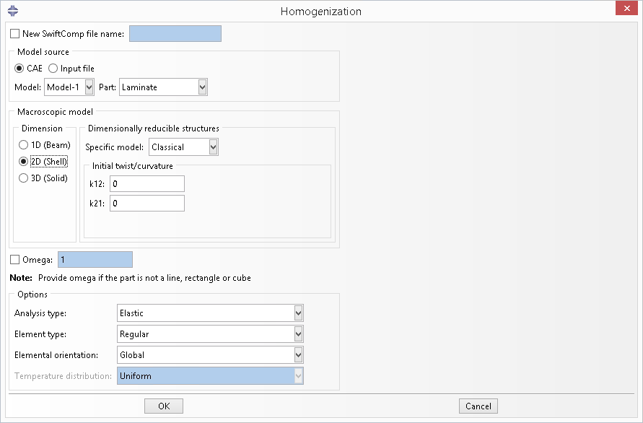
Fig. 2.1-21 Homogenization dialog box-use 2D shell model

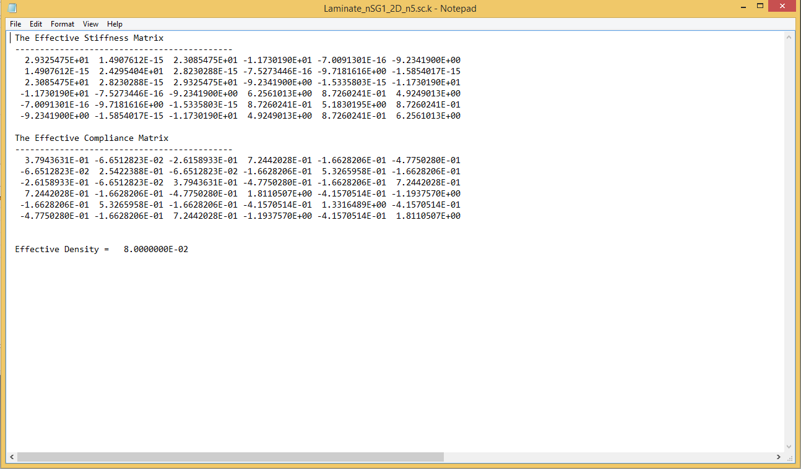
Fig. 2.1-22 ABD matrix of classical plate/shell model

2.1.3 Dehomogenization
Click the dehomogenization button in the red frame of Fig. 2.1-23, the dehomogenization dialog box in Fig. 2.2-24 (a) will pop out.
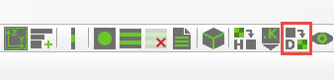
Fig. 2.1-23 Dehomogenization button

There are two methods provided to choose the SG we have created previously. The first method is to choose the sg_name shown in the list while the SG model source is ‘CAE’. The second method is to choose the SwiftComp input file ‘Laminate_nSG1_3D_n5.sc’ if the SG model source is ‘SwiftComp input file’. Using this method, the Analysis type and the Macroscopic model type must be specified correctly, otherwise there will be an error message popped up (Fig.2.1-24 (b)). For both methods, the SwiftComp input file (.sc), the homogenization result files (.sc.k and .sc.opt) should be in the current work directory, which are needed in the dehomogenization. If you used CAE to generate the model, carried out the homogenization, the files are already stored in the work directory.

Specify the required inputs as shown in Fig. 2.2-24. Please refer to SwiftComp™ manual for meaning of the global behavior parameters.

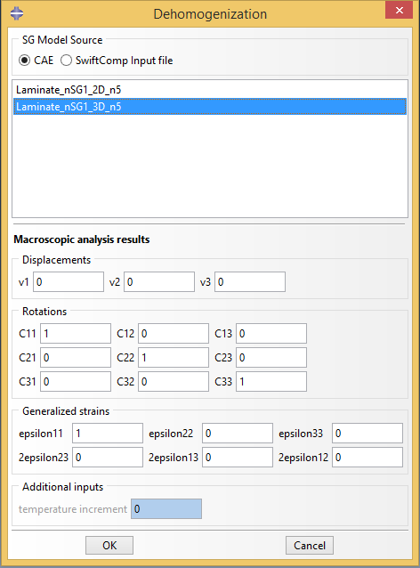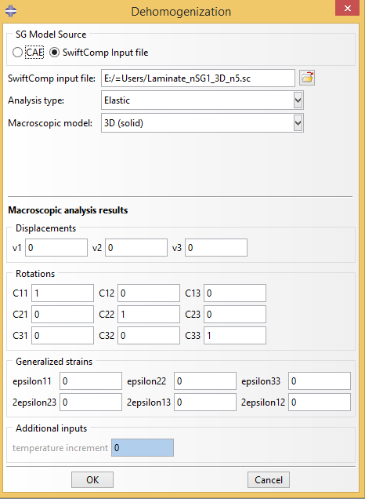
- Two methods to choose the homogenizaiton results files (.sc, .sc.k, .sc.opt)
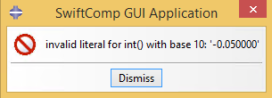
- Error message if choose the wrong macroscopic model type
Fig. 2.1-24 Dehomogenization parameters for 3D solid model

Click OK and wait for SwiftComp™ to finish the computation. The post-processing results will be automatically loaded. However the user need to switch to the Visualization model to view all the field results components, including displacement (U1, U2, U3) and its magnitude, six nodal strain components (EN11, EN22, EN33, 2EN23, 2EN13, 2EN12) and the derived quantities such as Mises strain, six nodal stress components (SN11, SN22, SN33, SN23, SN13, SN12) and the derived quantities such as Mises stress. The nodal stress SN12 components is shown in Fig. 2.1-25. In the odb tree, sections ‘nlayer - 1’, ‘nlayer - 2’ are created, with each section containing the plies with the same material properties and the same layer angle.
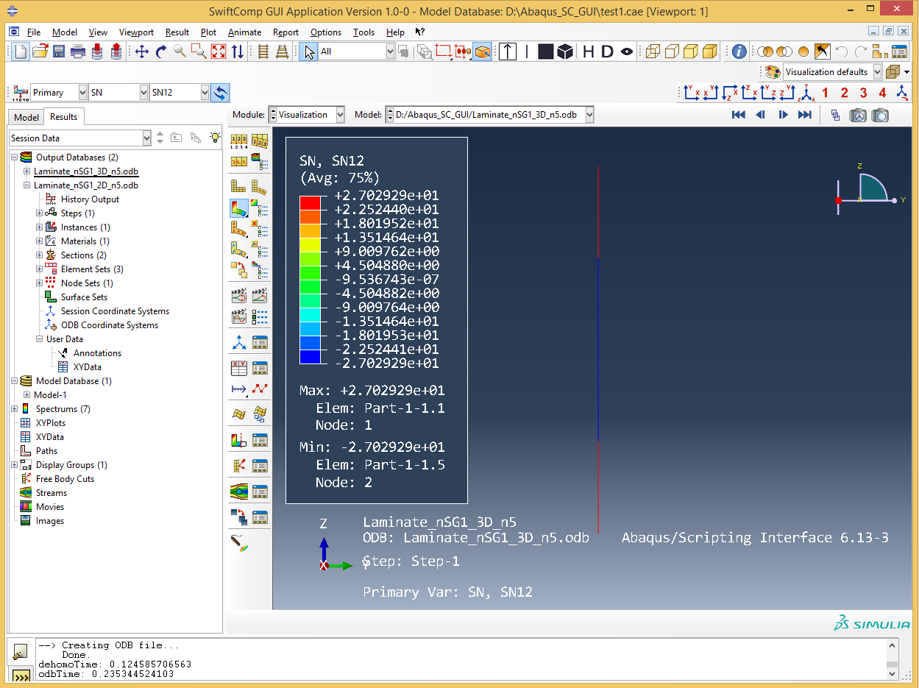
Fig. 2.1-25 Dehomogenization results of 3D model

If using shell model, choose the SwiftComp input file ‘Laminate_nSG1_2D_n5.sc’ and specify the required inputs as shown in Fig. 2.1.26. Please refer to SwiftComp™ manual for meaning of the global behavior parameters.
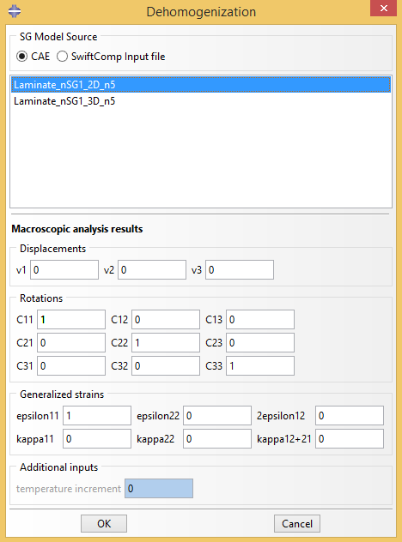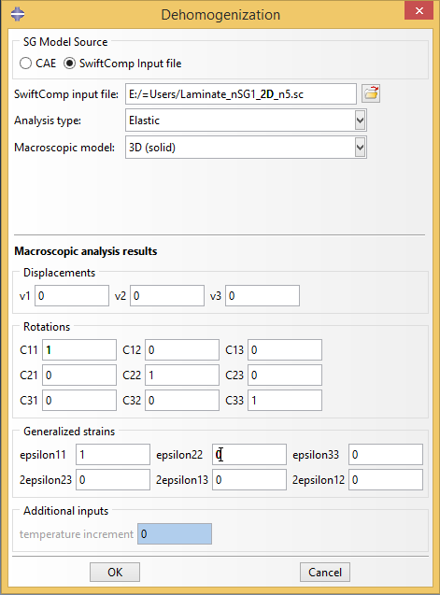
Fig. 2.1-26 Dehomogenization parameters for shell model

Contour plots are available for all local fields. In the odb tree, sections ‘nlayer - 1’, ‘nlayer - 2’ are created, with each section containing the plies with the same material properties and the same layer angle. The nodal stress SN12 component is shown in Fig. 2.1-27.
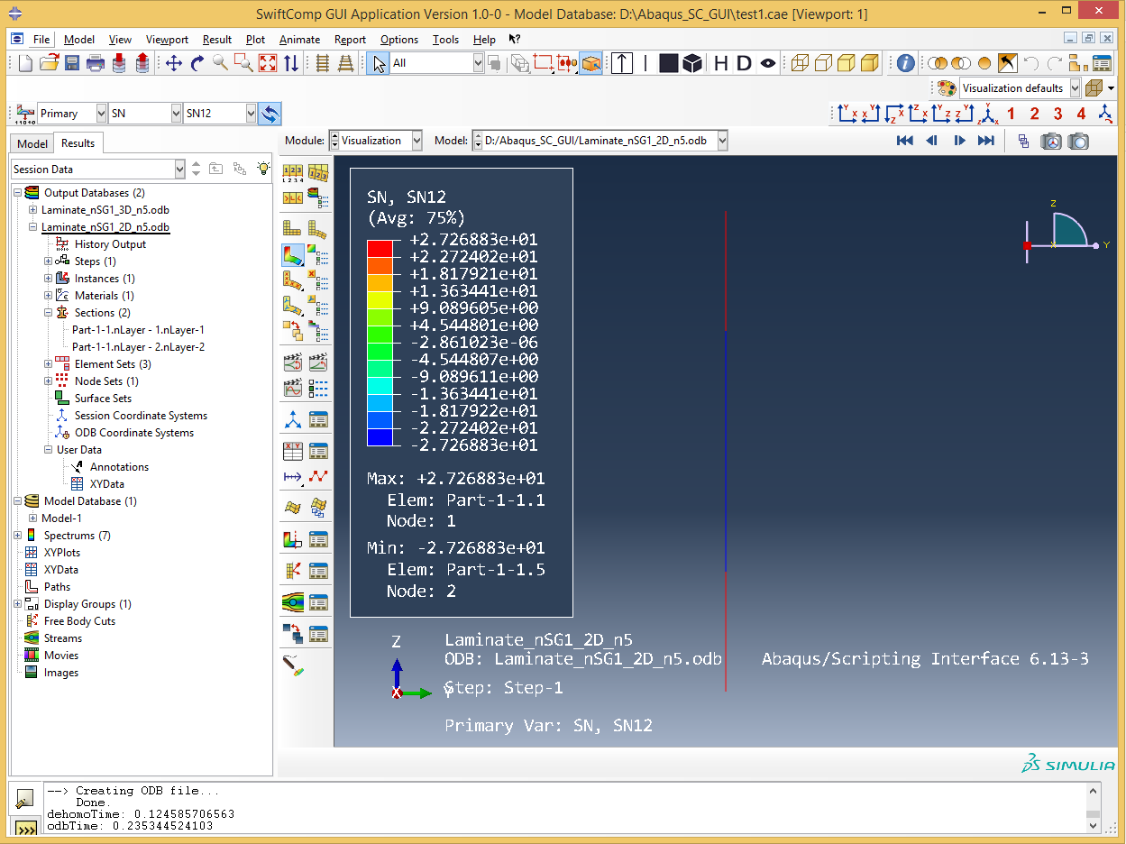
Fig. 2.1-27 Dehomogenization results of shell model

2.2 Square Pack Microstructure (2D SG)

2.2.1 2D SG preparation
In this example, assume that both fiber and matrix are isotropic materials (Material Fiber: Young’s modulus E = 379.3 GPa, Poisson’s ratio = 0.1; Material Matrix: Young’s modulus E = 68.3 GPa, Poisson’s ratio = 0.3). Create Materials in the Property module as shown in Fig. 2.2-1.

Material | E
Fiber | 379.3 GPa | 0.1
Matrix | 68.3 GPa | 0.3

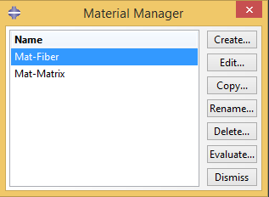
Fig. 2.2-1 Material creation

Then click the 2D SG button in the red frame in Fig. 2.2-2 so that the dialog box in Fig. 2.2-3 will pop out. The square pack microstructure SG has width 1.0. The user is allowed to choose the volume fraction or radius of fiber and interphase. If there is no interphase, the text field in the Interface group box is set to the default value 0.0.
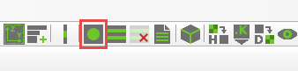
Fig. 2.2-2 Create 2D common SG button

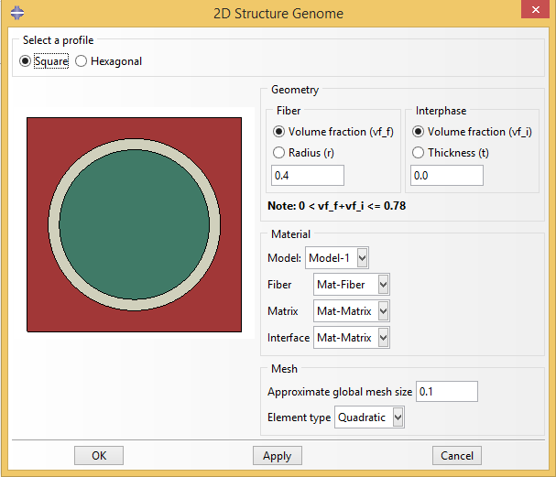
Fig. 2.2-3 Create 2D SG dialog box

After setting all the parameters as shown in Fig. 2.2-3, click OK to create the SG (Fig. 2.2-4).
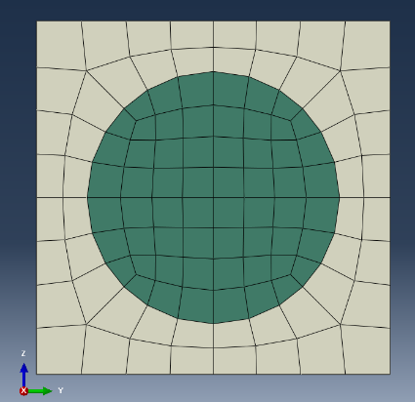
Fig. 2.2-4

2.2.2 Homogenization
Click the homogenization button in the red frame of Fig. 2.2-5, a dialog box in Fig. 2.2-6 will pop up. In this example, we choose the 3D solid macro model, then the default file name will be ‘sqrP2_nSG2_3D_S8R.sc’. Click OK and wait for preparing the input file of SwiftComp™ and homogenization. After the computation of SwiftComp™, the effective properties will pop up automatically (Fig. 2.2-7).


Fig. 2.2-5 Homogenization button

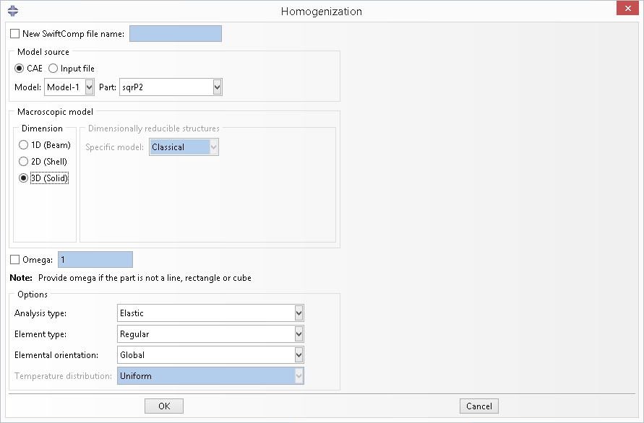
Fig. 2.2-6 Homogenization dialog box-use 3D solid model

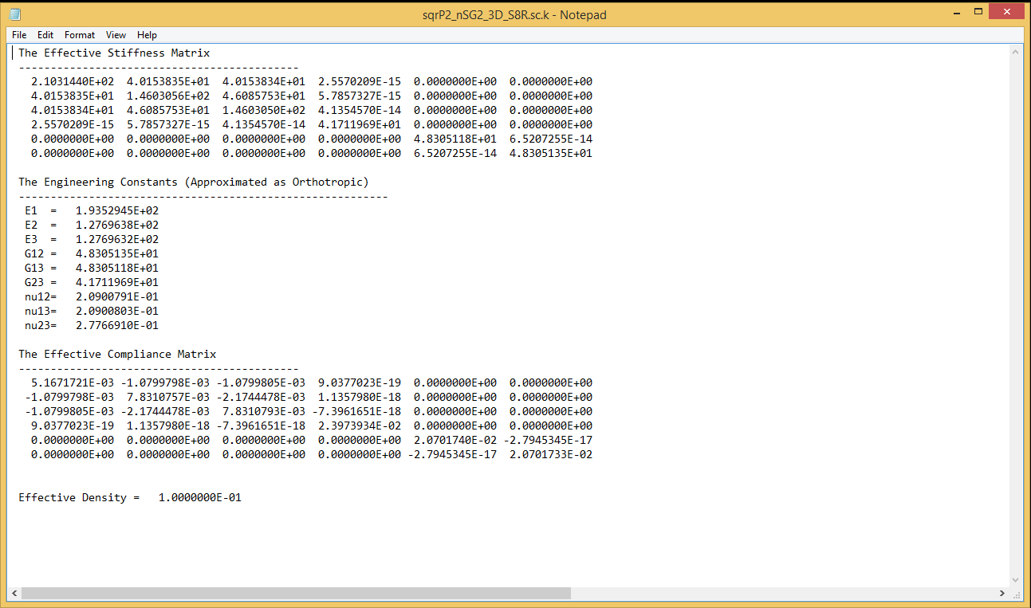
Fig. 2.2-7 Effective properties of 3D solid model

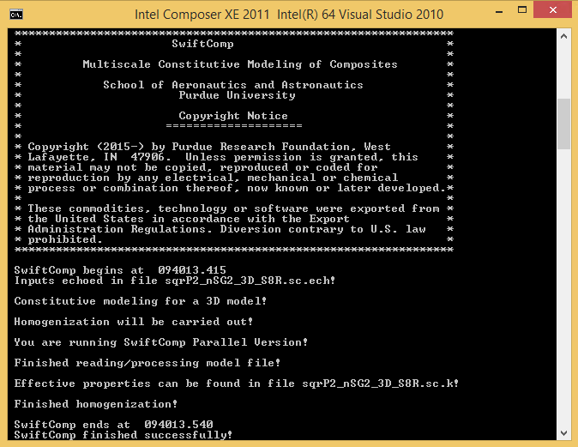
Fig. 2.2-8 Command line window shows the progress and error messages

2.2.3 Dehomogenization
Click the dehomogenization button in the red frame of Fig. 2.2-9, the dehomogenization dialog box in Fig. 2.2-10 will pop out. We can choose the SG from CAE or choose SwiftComp input file ‘sqrP2_nSG2_3D_S8R.sc’, and then specify the required inputs as shown in Fig. 2.2-10.

Fig. 2.2-9 Dehomogenization button

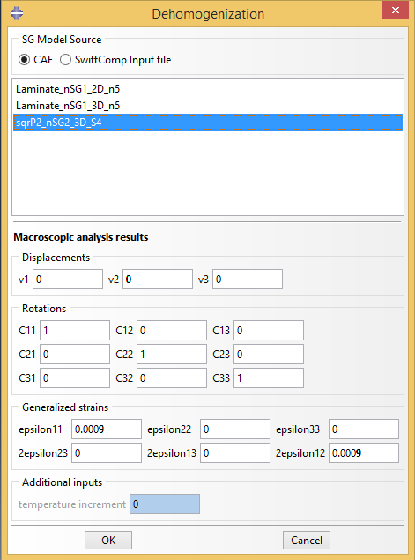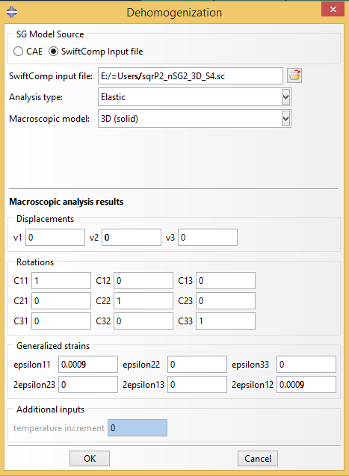
Fig. 2.2-10 Dehomogenization parameters for 3D solid model

Click OK and wait for SwiftComp™ to finish the computation. Switch to the Visualization model, the user is able to view all the field results components. In the odb tree, 2 sections are created, with each section containing the same material properties. The nodal stress SN11 component is shown in Fig. 2.2-11.

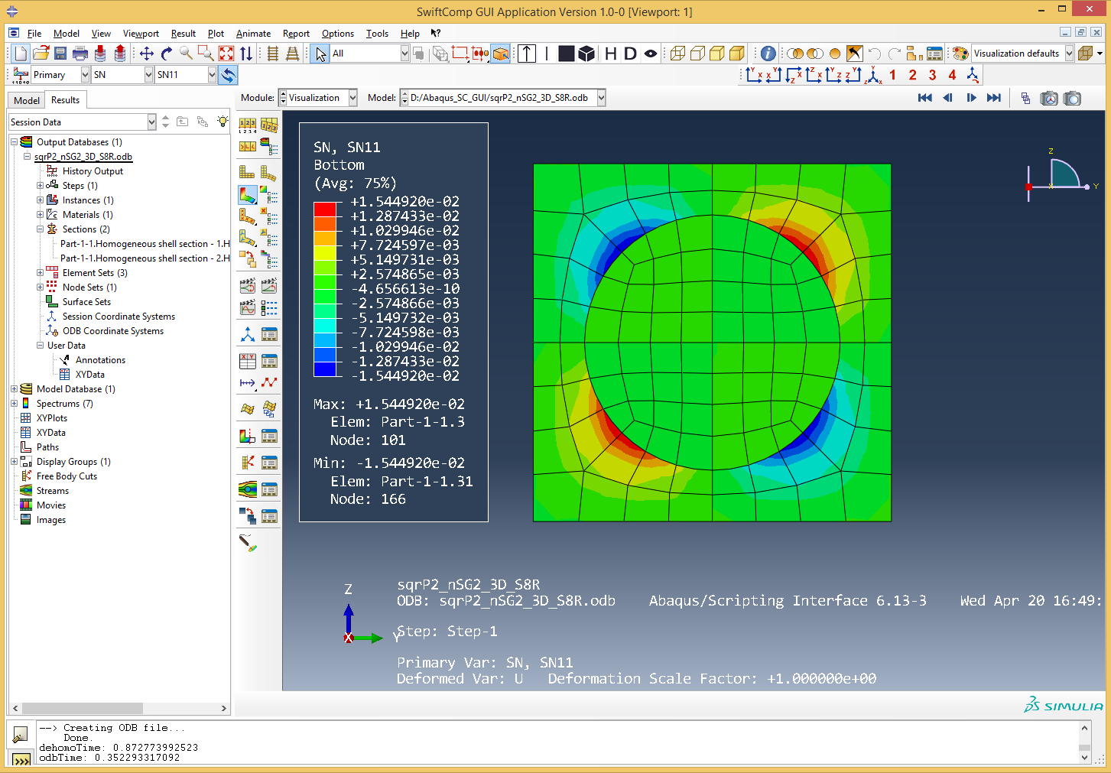
Fig. 2.2-11 Dehomogenization results of 3D model

2.3 Spherical Inclusion Microstructure with Interphase (3D SG)

2.3.1 3D SG preparation
In this example, assume that both fiber and matrix are isotropic materials (Material Fiber: Young’s modulus E = 379.3 GPa, Poisson’s ratio = 0.1; Material Matrix: Young’s modulus E = 68.3 GPa, Poisson’s ratio = 0.3; Material Interphase: E₁=117.0 GPa, E₂=E₃=8.54 GPa, ₁₂=₁₃=0.278, ₂₃=0.5, G₁₂=G₁₃=3.9 GPa, G₂₃=2.83 GPa).
Create Materials in the Property module as shown in Fig. 2.3-1.

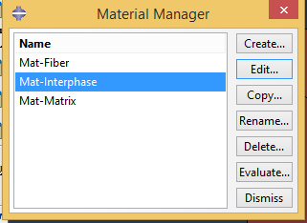
Fig. 2.3-1 Material creation
Then click the 3D common SG button in the red frame in Fig. 2.3-2 so that the dialog box in the Fig. 2.2-3 will pop out. This 3D SG has length 1.0 in every dimension. The user is allowed to choose the volume fraction or radius of inclusion and interphase. If there is no interphase, the text field in the Interface group box is set to be the default value 0.0.
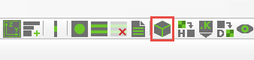
Fig. 2.3-2 Create 3D common SG button

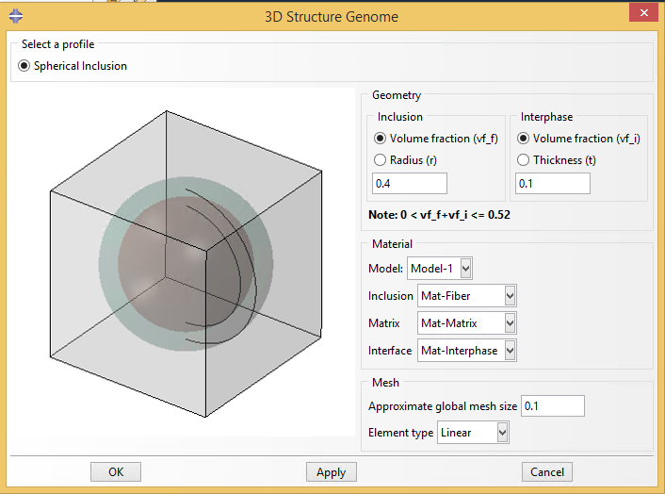
Fig. 2.3-3 Create 3D SG dialog box

After setting all the parameters as shown in Fig. 2.3-3, click OK to create the SG (Fig. 2.3-4).
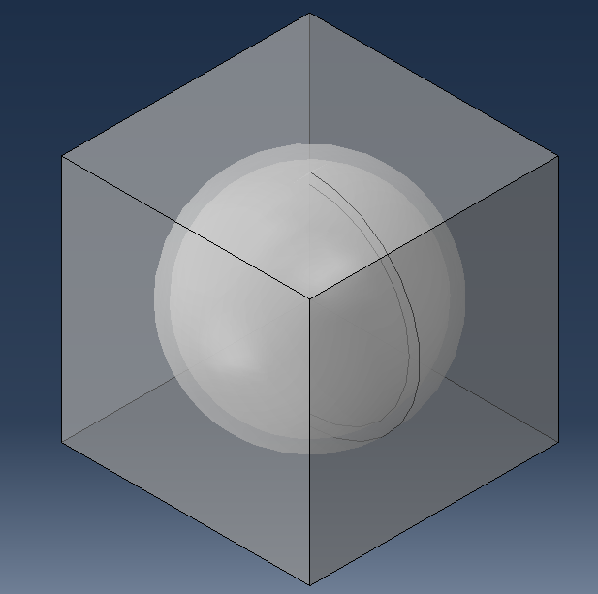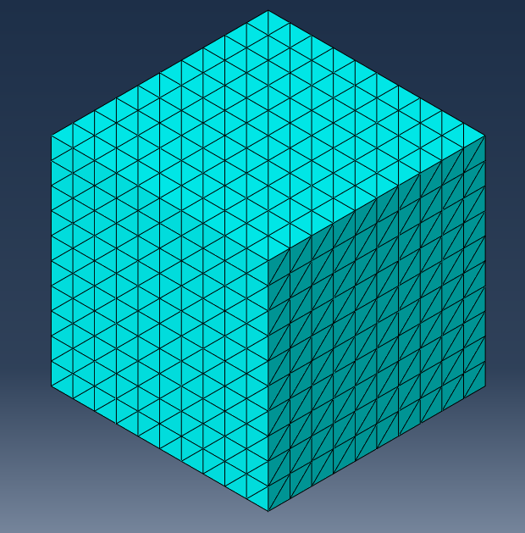
Fig. 2.3-4 The created 3D SG

2.3.2 Homogenization
Click the homogenization button, a dialog box in Fig. 2.3-5 will pop up. In this example, we choose the 3D solid macro model, then the default file name will be ‘inclusionP3_nSG3_3D_C3D4.sc’. Click OK and wait for preparing the input file of SwiftComp™ and homogenization. After the computation of SwiftComp™, the effective properties will pop up automatically (Fig. 2.3-6).

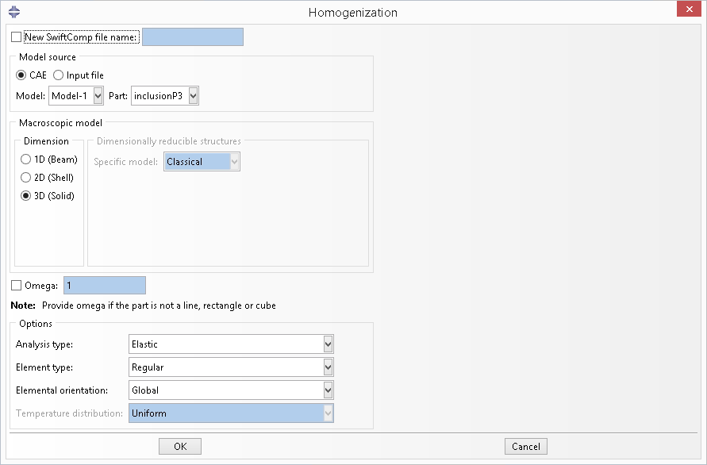
Fig. 2.3-5 Homogenization dialog box-use 3D solid model

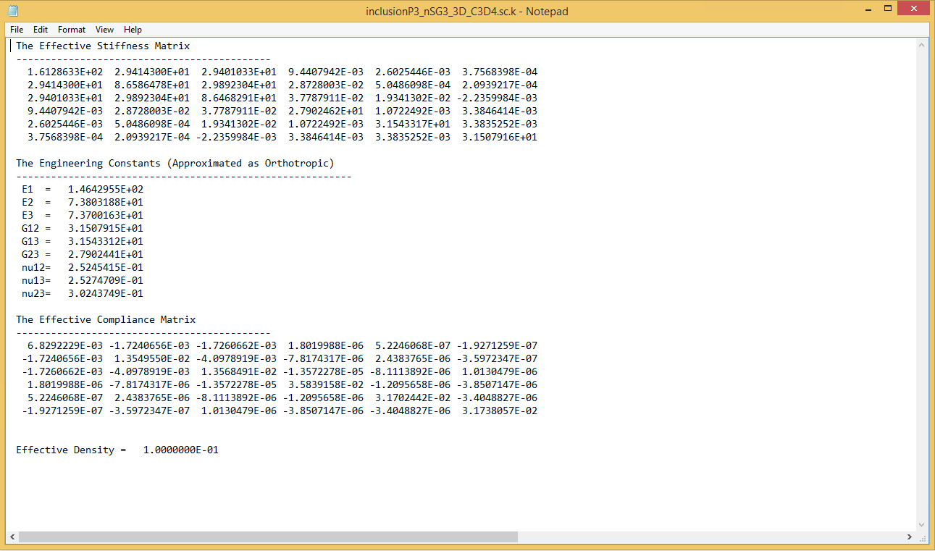
Fig. 2.3-6 Effective properties of 3D solid model

2.3.3 Dehomogenization
Click the dehomogenization button, the dehomogenization dialog box in Fig.2.3-7 will pop out. We can choose the SG from CAE or choose SwiftComp input file ‘inclusionP3_nSG3_3D_C3D4.sc’, and then specify the required inputs as shown in Fig. 2.3-8.
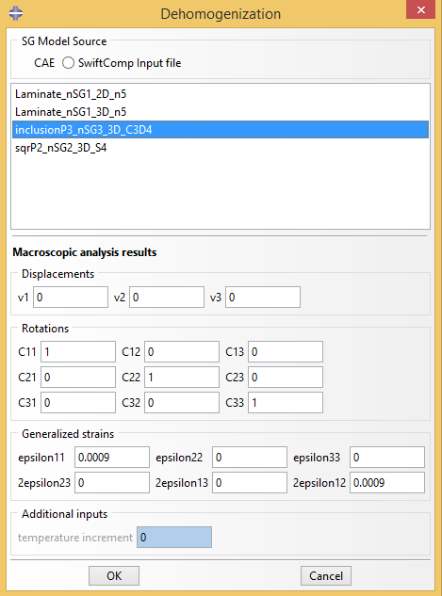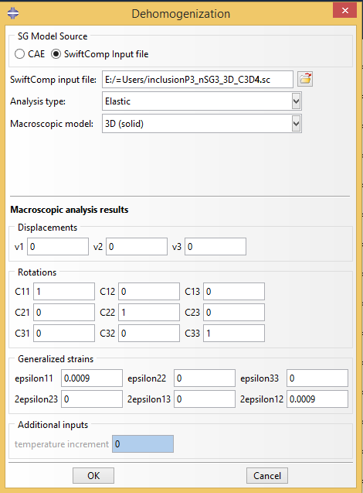
Fig. 2.3-8 Dehomogenization parameters for 3D solid model

Click OK and wait for SwiftComp™ to finish the computation. Switch to the Visualization model, the user is able to view all the field results. In the odb tree, 3 sections are created, with each section containing the same material properties.
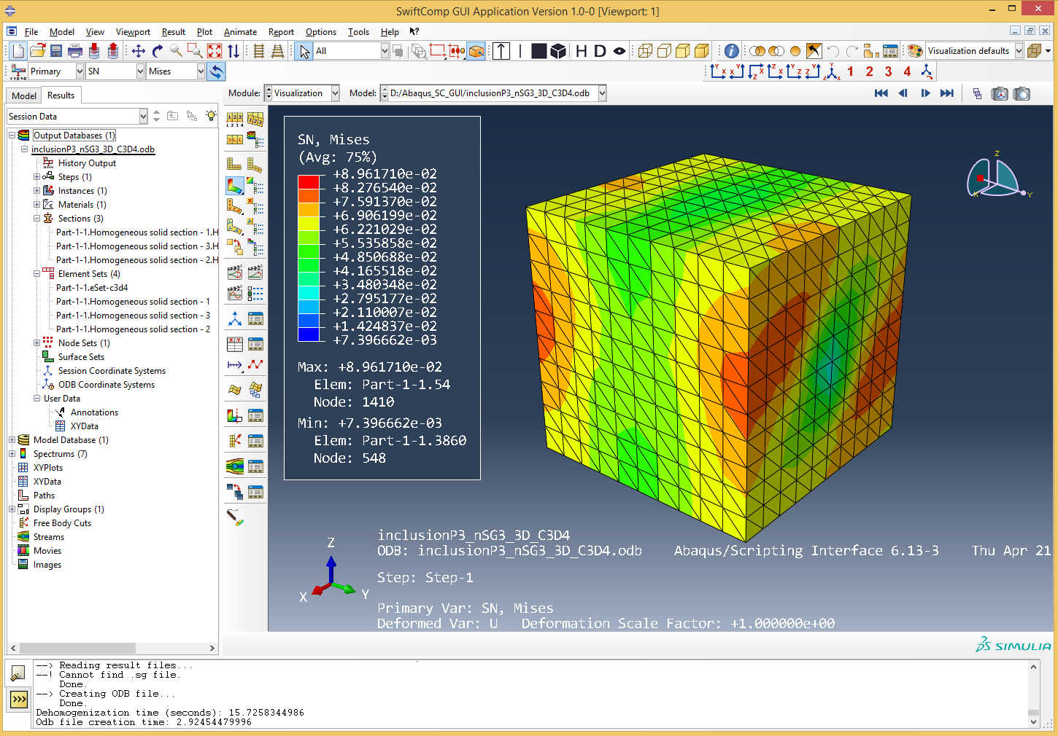
Fig. 2.2-10 Dehomogenization results of 3D model

2.4 Summary

Common SG function provides users a convenient way to quickly build the geometry of common SG, and easily specify material properties they want to test. Users can also test other capabilities of common SG function if they are interested.

3.0 CREATE USER-DEFINED MODEL

CREATE USER-DEFINED MODEL

Although common SG function provides users a convenient way to build the geometry of the most common models, often users need to build their own models according to the microstructure they are analyzing. Without using the common SG function, this chapter will illustrate how to build 2D square pack microstructure SGs similar to the above common models. Example is not given for 3D SG since the process is exactly the same as creating a 3D part in Abaqus with information of elements, materials and section assignment. The only difference between user-defined model and common SG model is the generation of the SG. The homogenization and dehomogenization steps are the same. So we will only focus on the SG preparation in this chapter.

3.1 Square Pack Microstructure (2D SG)

Step 1: Create materials
To create a customized 2D SG, the first step is to create the materials in Abaqus GUI. For simplicity, this example uses the material properties in Section 2.3.

Step 2: Set work plane
As stated in Section 1.2.1 Geometry, 2D SG must in Y-Z plane. To set work plane to the Y-Z plane, click the work plane button in the red frame shown in Fig. 3.1-1. In the dialog box popped out in Fig. 3.1-2, choose the model and give the part name for the 2D SG, choose the SG dimension to be 2D. The work plane button will create a datum plane and a datum axis in the part.
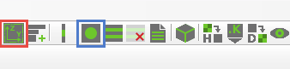
Fig. 3.1-1 work plane button (in the red frame) and 2D SG button (in the blue frame)
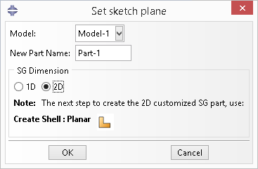
Fig. 3.1-2 work plane button dialog box
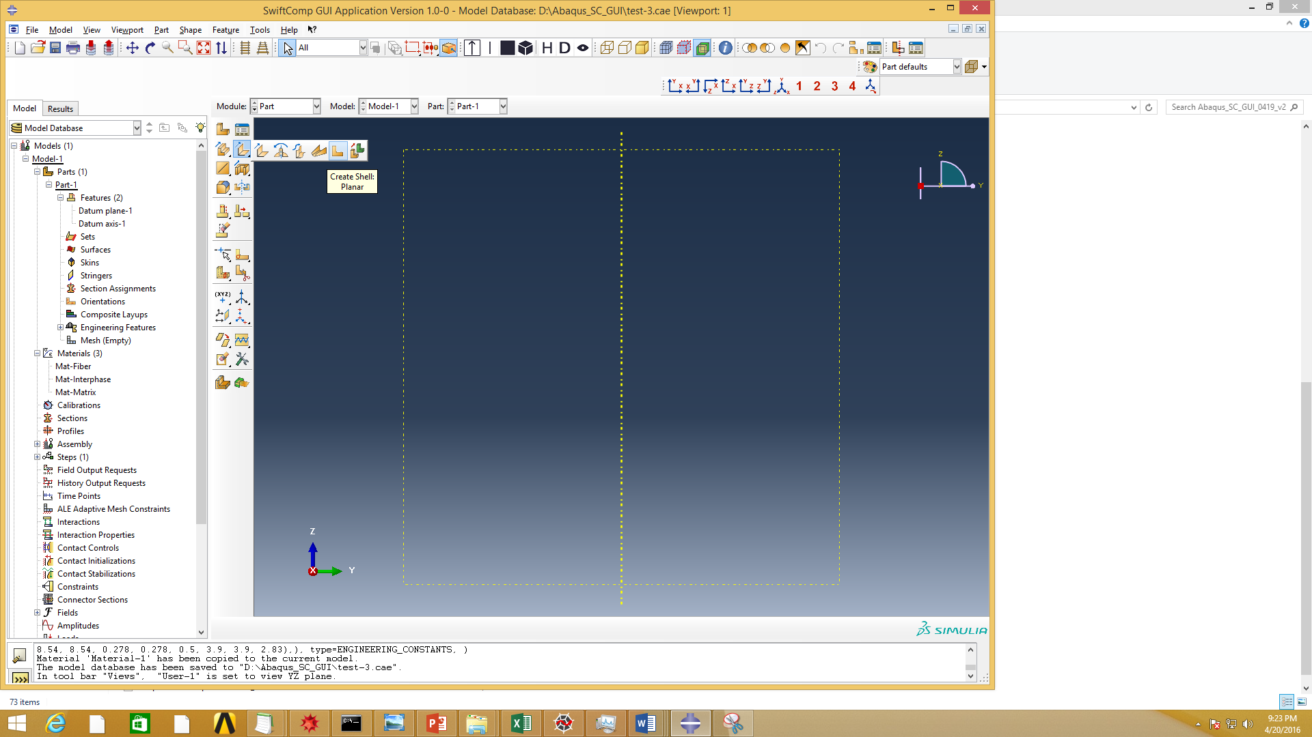
Fig. 3.1-3 After use the work plane button

Step 3: Create geometry of 2D customized SG
Follow the tips given in the work plane button dialog box, the next step is to create the 2D SG geometry using tool button ‘Create Shell: Planar’ in Part module. Follow the procedure, the user can create the geometry shown in Fig. 3.1-4(a). By Partition Face, the user can create the square pack microstructure as shown in Fig. 3.1-4(b).
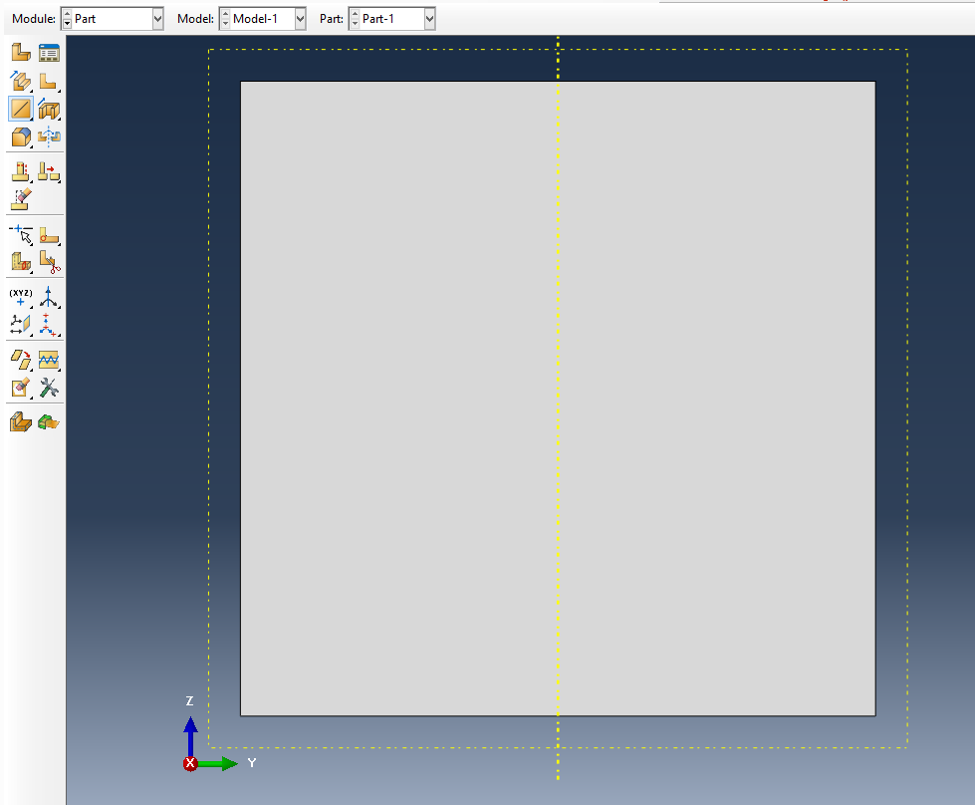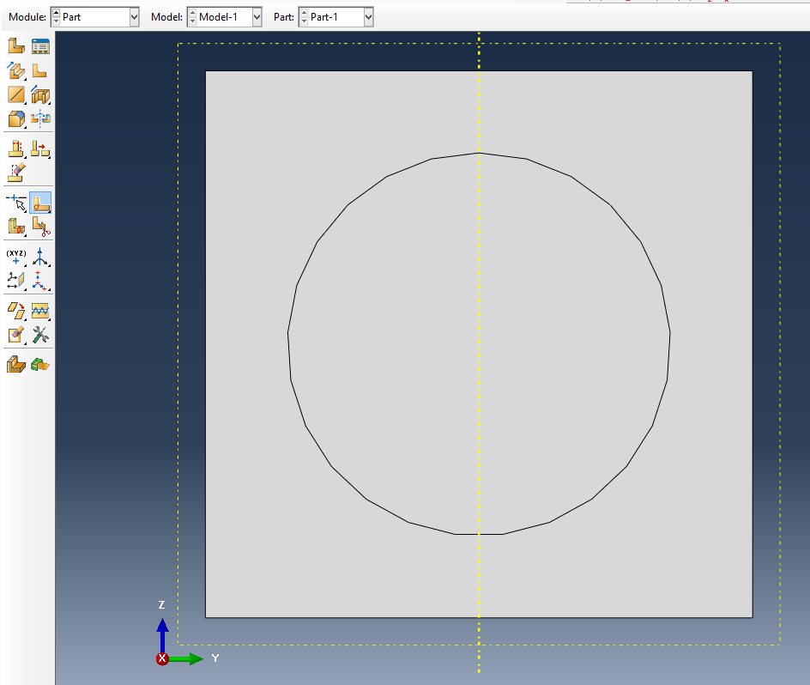
(a) (b)
Fig. 3.1-4 The square pack microstructure

Step 4: Assign material sections, create mesh for the 2D customized SG
The user can then create material sections, assign material sections to the geometry and create mesh for the 2D customized SG, which are exactly the same as what one needs to do for a general Abaqus model. Please refer to Section 1.2 for the general remarks.

In this example, Global seeds are applied, and the mesh is generated using the Mesh Controls setting: Quad-dominated Element Shape, Free-Technique, Advanced front–use mapped meshing where appropriate Algorithm. The mesh shown in the Fig. 3.1-5 is quite irregular but can be used for homogenization and dehomogenization analysis. However, if use Medial axis Algorithm while keep the other settings, although the mesh generated looks better (Fig. 3.1-6), error will occur because of the mismatch of the periodic node pairs at the SG boundary edges. The error message can be checked in the command window as shown in Fig. 3.1-7.
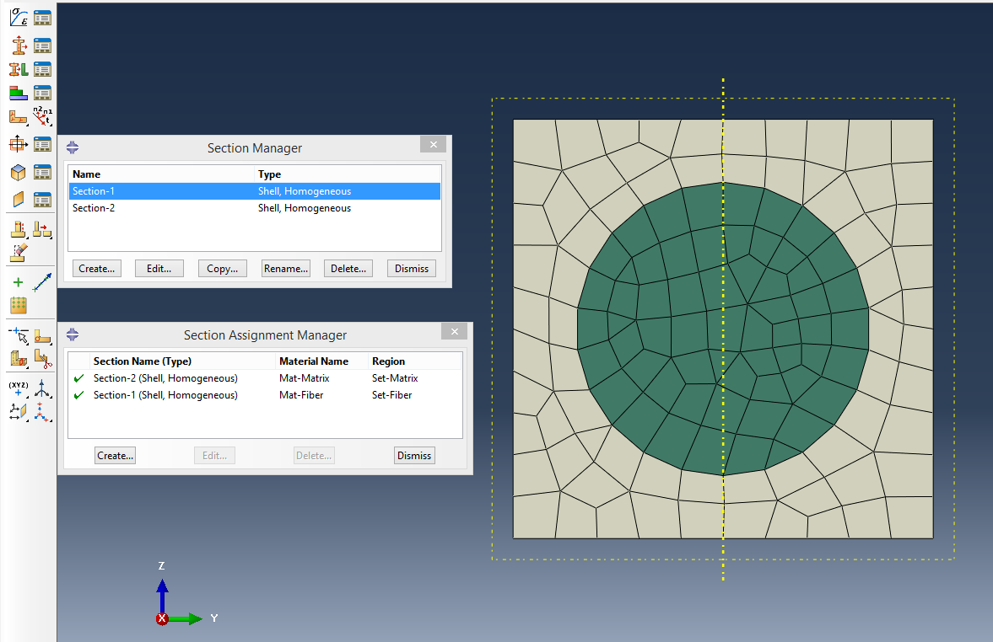
Fig. 3.1-5 The square pack microstructure

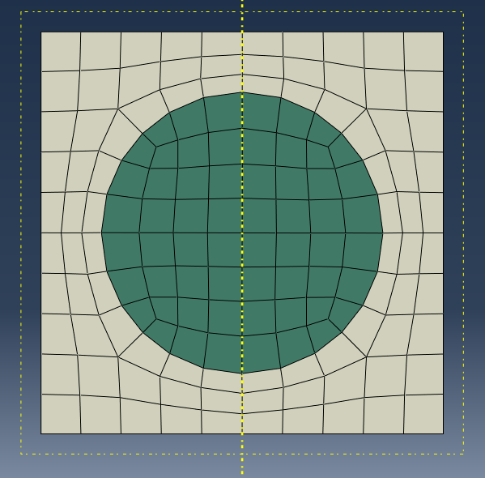
Fig. 3.1-6 The square pack microstructure with mesh2- generated by ‘Medial axis Algorithm’

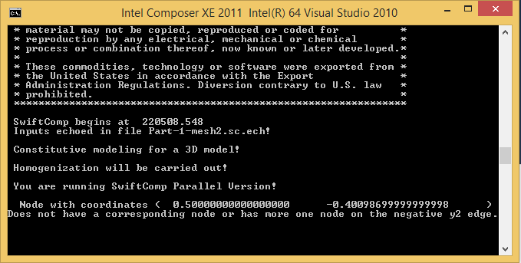
Fig. 3.1-7 The error message when use mesh2

Therefore the user should be skillful in generating good periodic mesh. Possible solutions can be:
- Choose mesh techniques wisely and do not allow the number of elements to change (Fig. 3.1-8).
- For symmetrical SGs, the user can first create 1/4 of the geometry for 2D SG, or 1/8 SG for 3D SG, then use the tools in Assembly module (Patten, Rotate, Merge (mesh)) to create new part (Fig. 3.1-9).
- Using other software to generate mesh, for example Hypermesh, Ansys, which allow more flexible mesh techniques to create periodic mesh. Then the models created can be imported to Abaqus.
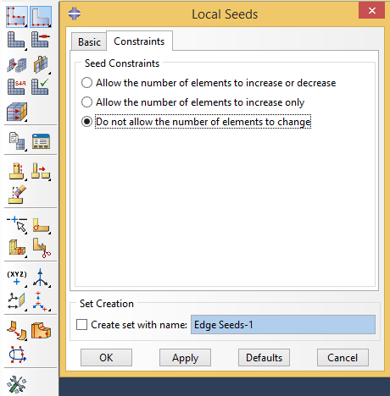
Fig. 3.1-8 Seed by edge and constraint the element number

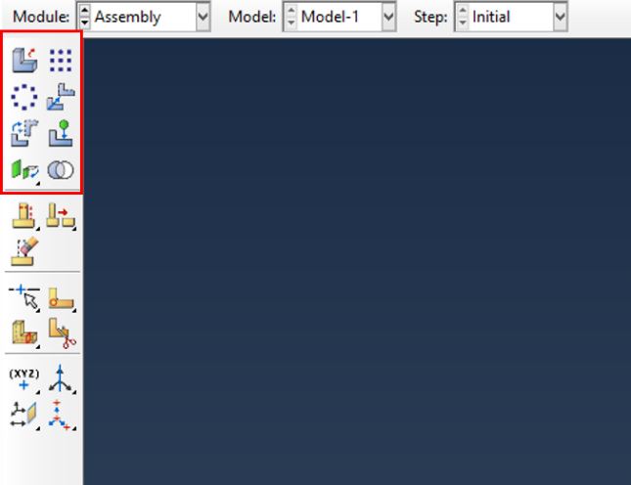
Fig. 3.1-9 Tools in Assembly may help in generating periodic mesh

3.2 Arbitrary Shape Inclusions Microstructure (2D SG)
One more user-defined model is shown here, which is a rectangle SG with two arbitrary inclusions. Users can understand how to create complex shape in Abaqus-SwiftComp GUI, and also know the capability of SwiftComp™ to calculate such models.

Step 1: Create materials and sections
In this example, assume that both inclusions and matrix are isotropic materials (Material 1: E = 379.3 GPa, = 0.1; Material 2: E = 279.3 GPa, = 0.1; Material 3: E = 68.3 GPa, = 0.3).
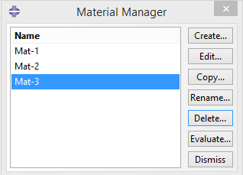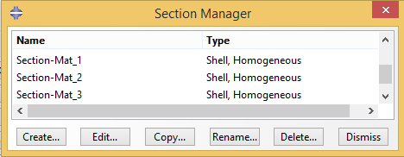
Fig. 3.2-1 Create materials and sections

Step 2: Set work plane
Following the procedure as shown in section 3.2 Step 2, the work plane of 2D SG can be created.

Step 3: Create geometry of 2D customized SG
First create the rectangular shell using points (-0.5, -1), (0.5, 1) as shown in Fig. 3.2-2(a).
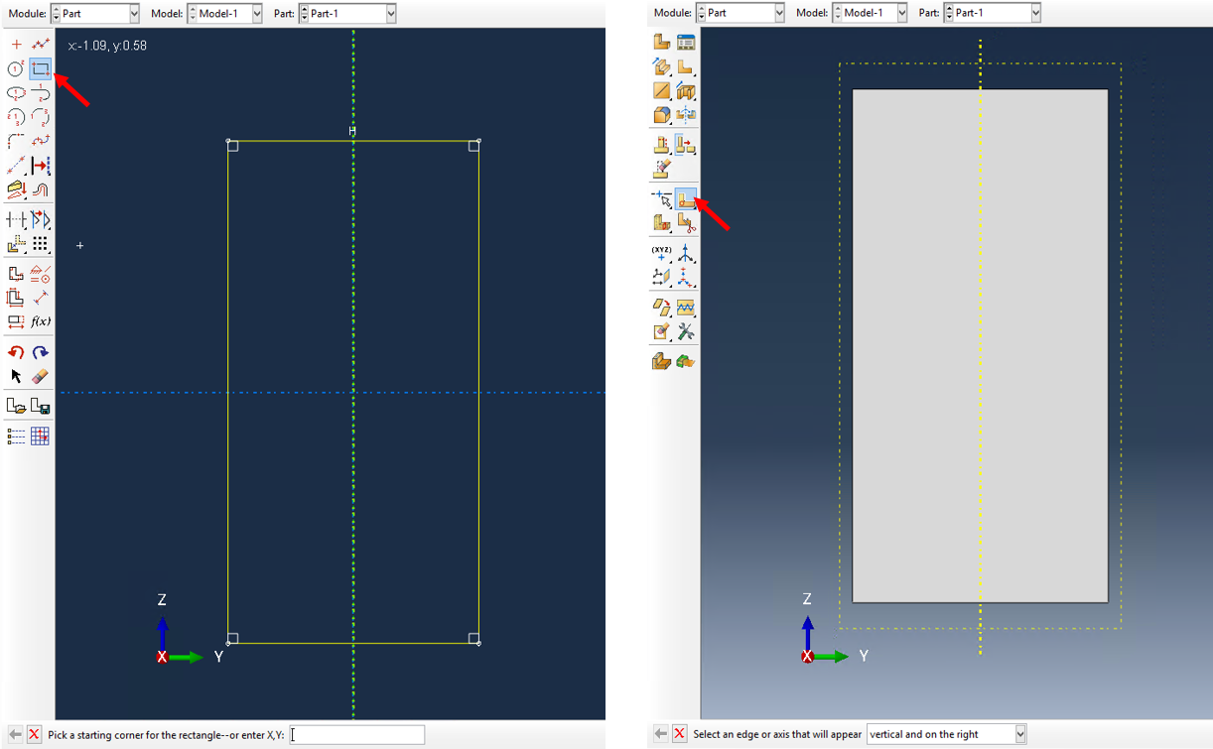
- (b)
Fig. 3.2-2 Create geometry of the SG

Click the tool button ‘Partition face: Sketch’ (Fig. 3.2-2 (b)), then create the isolated points (-0.2, 0.8, 0), (-0.3, 0.7, 0,), (-0.3, 0.4, 0), (-0.1, 0.6, 0), (0, 0.8, 0), (0, 0, 0), (-0.1, 0, 0), (-0.2, -0.3, 0), (0.1, -0.5, 0), (0.1, -0.3, 0) and (0.2, -0.1, 0) (see Fig. 3.2-3 (a)). Create splines through the points as shown in Fig. 3.2-3 (b).
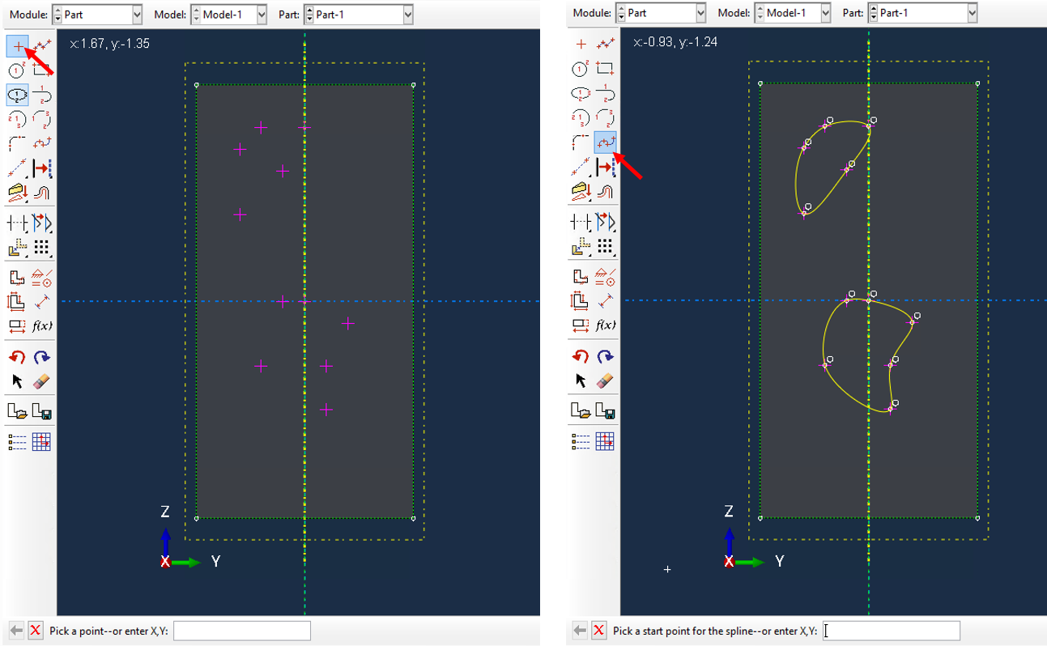 Fig. 3.2-3

Step 4: Assign material sections, create mesh for the 2D customized SG
In the property module, the user can assign the material sections created in the first step to the geometry (Fig. 3.2-4).
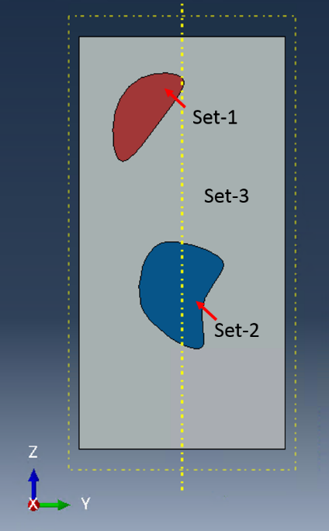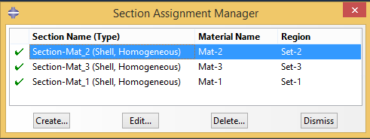
Fig. 3.2-4 Assign material sections

Step 5: Generate User-defined Model Mesh
In this example, Global seeds are applied, and the mesh is generated using the Mesh Controls setting: Quad-dominated Element Shape, Free-Technique, Advanced front–use mapped meshing where appropriate Algorithm. The mesh shown in the Fig. 3.2-5 is quite irregular but can be used for homogenization analysis. However, it can be seen that there is one element (highlighted in the yellow ellipse is abnormal. If use this mesh to do the dehomogenization, there will be an error message in the command window (Fig. 3.2-6). Such a mesh can be repaired as shown in Fig. 3.2-7.
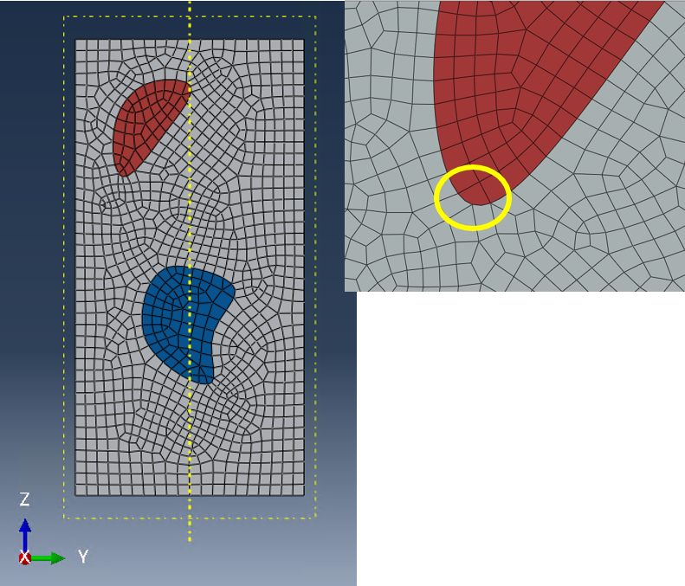
Fig. 3.2-5 Mesh need to be repaired

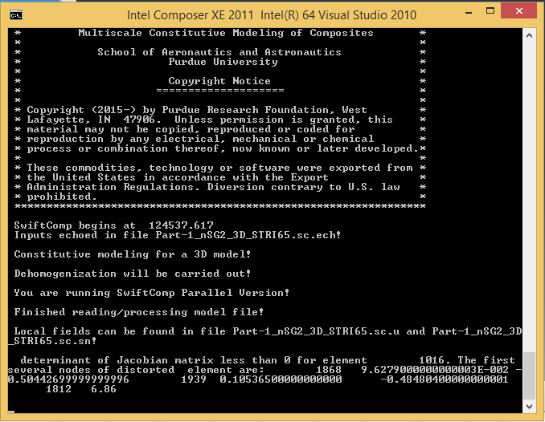
Fig. 3.2-6 Error message in dehomogenization
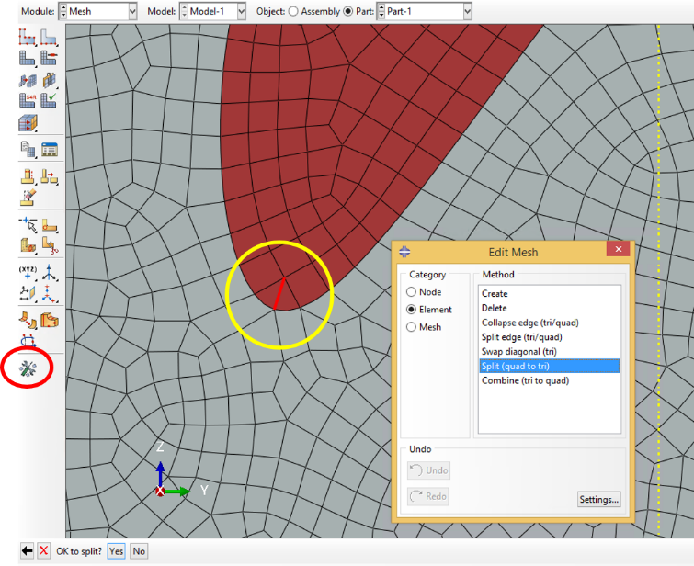
Fig. 3.2-7 repair the mesh

Step 6: Homogenization and dehomogenization
Click the homogenization button, and fill the dialog box as shown in the Fig. 3.2-8, the effective properties is obtained (Fig. 3.2-9).

Click the dehomogenization button, and fill the dialog box as shown in the Fig. 3.2-10, the local fields are obtained (Fig. 3.2-11).

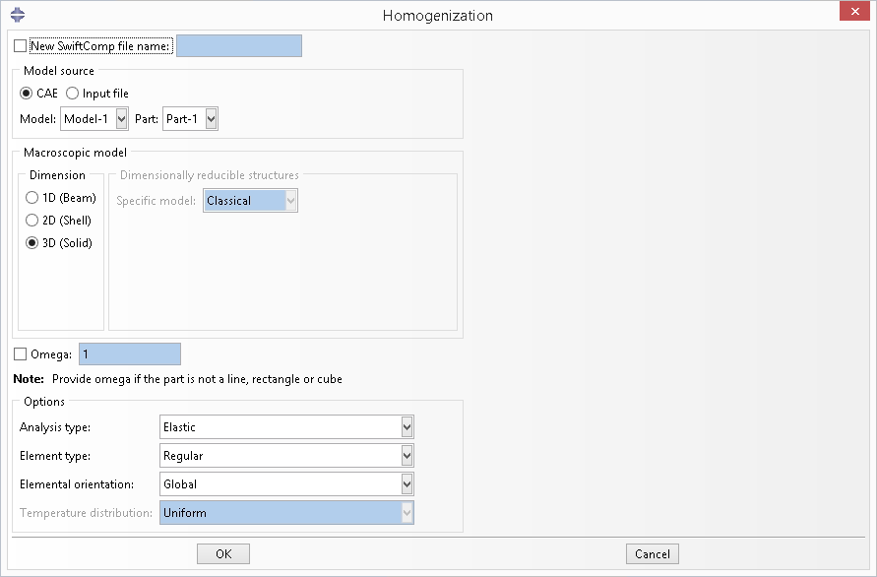
Fig. 3.2-8 Homogenization

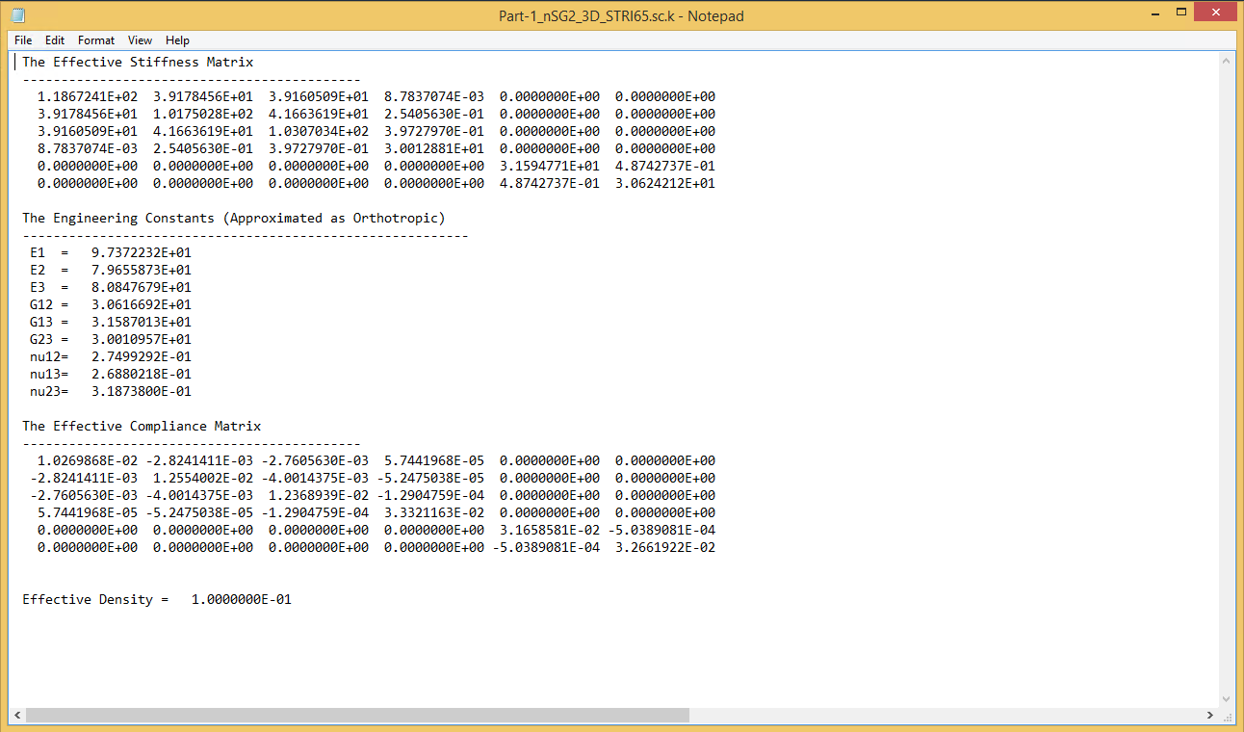
Fig. 3.2.9 Effective properties
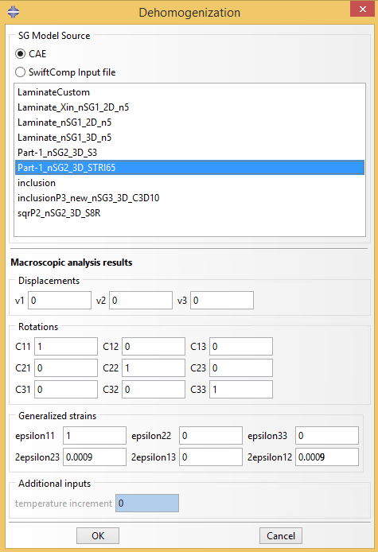
Fig. 3.3-10 Dehomogenization

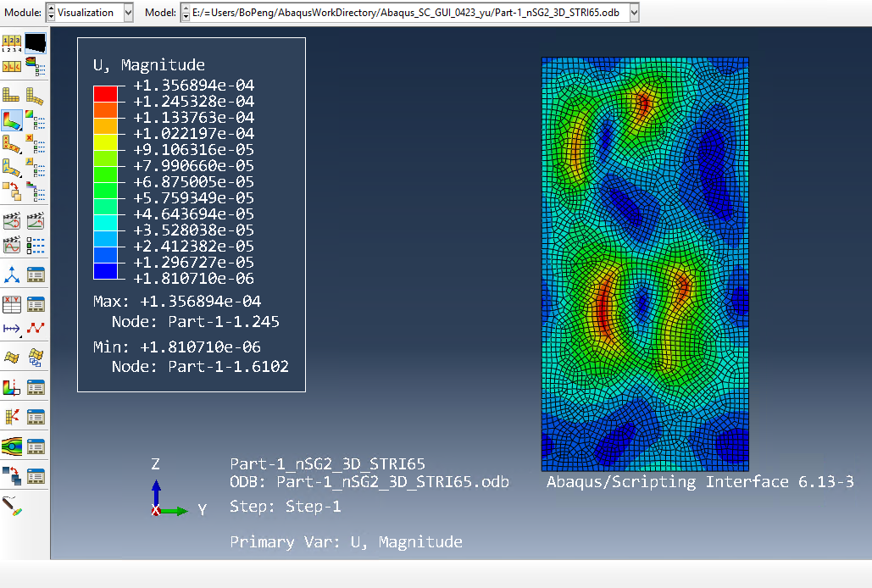
Fig. 3.3-11 Dehomogenization result: magnitude of displacement

3.3 Create Layups
Users can use function ‘New layups’ to create Solid-Composite sections which will be used later. There are two ways to do this. One is through fast generation, the other one is reading from file.

3.3.1 Fast generation
In this method, user can generate a layup through a rule, such as [0/90/45/-45]2s. User needs to first create a material. Then provide a new composite section name and the layup rule. The thickness at the last is for each ply. This method is only suitable for layups with a single material having different fiber orientations and all plies with the same thickness, which is the most common case in industry
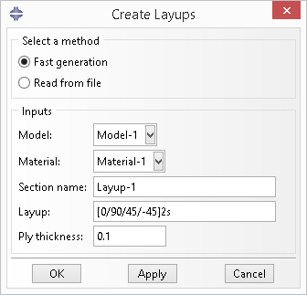

3.3.2 Read from file
In this method, user needs to prepare a material file and a layup file. To create composite sections, select ‘Read from file’ in the dialog box, and choose the material file and the layup file, then click ‘OK’. Both the material file and layup file should use the XMLformat and details are described below. Users are encouraged to have some basic knowledge on XML files. A quick and simple tutorial can be found at http://www.tutorialspoint.com/xml/index.htm.
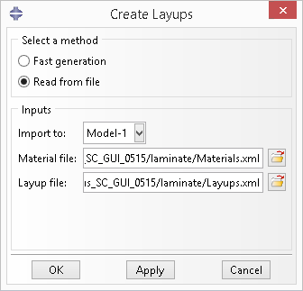
- Material file
The root element is ‘<materials></materials>’ and each ‘<material></material>’ sub-element store one material. For the current version, we can only deal with materials with density and elastic properties.
<materials>
<material type = "ENGINEERING CONSTANTS">
<id>1</id>
<name>iso5_1</name>
<density>1.860000E+03</density>
<e1>3.7000E+10</e1>
<e2>9.0000E+09</e2>
<e3>9.0000E+09</e3>
<g12>4.0000E+09</g12>
<g13>4.0000E+09</g13>
<g23>4.0000E+09</g23>
<nu12>0.28</nu12>
<nu13>0.28</nu13>
<nu23>0.28</nu23>
</material>
<material>
...
</material>
...
</materials>

Each material has a ‘type’ attribute, which has the same definition as Abaqus, ISOTROPIC, ENGINEERING CONSTANTS, ORTHOTROPIC or ANISOTROPIC. For each material, user needs to provide a unique ‘id’ and ‘name’. The ‘density’ is optional. When omitted, it will use the default value 1.0. The components of elastic properties for each type are the same as those in Abaqus, and the arrangement of components will not be a problem. For ISOTROPIC, we have 2 components, ‘e’ and ‘nu’. For ENGINEERING CONSTANTS, we have 9 components, ‘e1’, ‘e2’, ‘e3’, ‘g12’, ‘g13’, ‘g23’, ‘nu12’, ‘nu13’ and ‘nu23’. For ORTHOTROPIC, we have 9 components, ‘d1111’, ‘d1122’, ‘d2222’, ‘d1133’, ‘d2233’, ‘d3333’, ‘d1212’, ‘d1313’ and ‘d2323’. For ANISOTROPIC, we have 21 components, ‘d1111’, ‘d1122’, ‘d2222’, ‘d1133’, ‘d2233’, ‘d3333’, ‘d1112’, ‘d2212’, ‘d3312’, ‘d1212’, ‘d1113’, ‘d2213’, ‘d3313’, ‘d1213’, ‘d1313’, ‘d1123’, ‘d2223’, ‘d3323’, ‘d1223’, ‘d1323’ and ‘d2323’.

- Layup file
The root element is ‘<layups></layups>’ and each ‘<layup></layup>’ sub-element stores one layup.
<layups>
<layup>
<id>1</id>
<name>layup1</name>
<data>
0.0003810000000 3 0
0.0005099999960 4 0
0.0095400001224 2 20
</data>
</layup>
...
</layups>

For each layup, user need to provide a unique ‘id’ and ‘name’. In the ‘<data></data>’ sub-element, each line is a ply, where the first number is the thickness, the second one is the material id defined in materials.xml and the last one is the fiber orientation angle in degrees.

3.4 Cross-Section with Arbitrary Shape

3.4.1 Laminate in the GUI
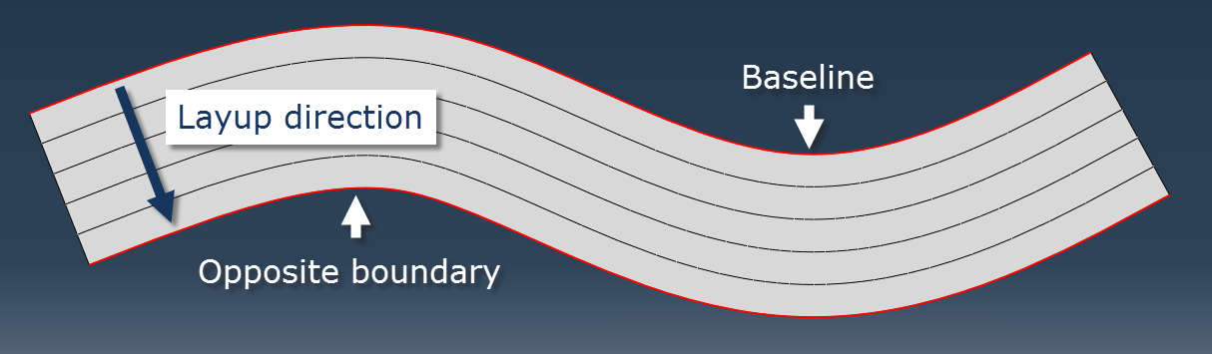

As shown in the figure, once the direction of layup is decided, the baseline is defined as the starting edge of the layup and the opposite boundary is the ending edge.

3.4.2 Dialog box
Clicking the icon button will activate the ‘Assign Layups’ dialog box, shown as below.
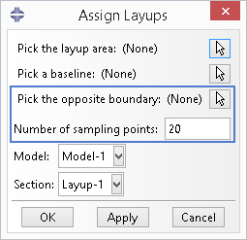

A layup area is the whole segment face before partitioning into different layers and the baseline is shown as in the figure above. These two objects are required for all type of laminates. The next two inputs, the opposite boundary and number of sampling points, are required only when the baseline and opposite boundary are not straight lines. The sampling points are used to replicate those curved edges in Abaqus sketch module. The more sampling points, the more accurate the geometry will be. But large number of points will greatly reduce the speed of building the part. The last two dropdown lists are for users to choose composite layups.
Clicking the icon button will activate the ‘Erase Layups’ dialog box, shown as below.
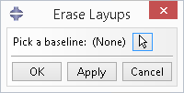

If a layup is assigned mistakenly, user can use this function to delete the wrong assignment. The baseline is the same as the one when assigning the layup. This function will help user to delete section assignments, sets and erase lines in the partition sketch, so that user can re-assign the area without worrying about duplicate or conflicting sets or section assignments.

3.4.3 Prerequisite
Before using the “Assign Layups” function, user needs to provide the geometry of the cross-section, materials and composite sections.

3.4.4 Example
Step 1: Set work directory
Menu > File > Set Work Directory.... Select the directory where you want to put all relative files, .cae, .inp, .sc, etc.
Step 2: Create materials
Module > Property > Create Material . Create two materials, Material-1 and Material-2, with properties you want.
Step 3: Create composite sections
User can create layups using functions described in section 3.3, or using Abaqus’s own functions by hand, which is described below.
Module > Property > Create Section . Create three sections, Layup-1, Layup-2 and Layup-3, shown as below. Either Solid-Composite or Shell-Composite is fine. Here we use Solid-Composite sections.
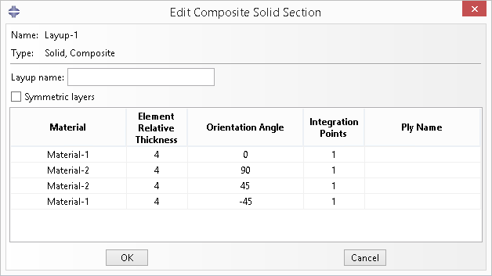

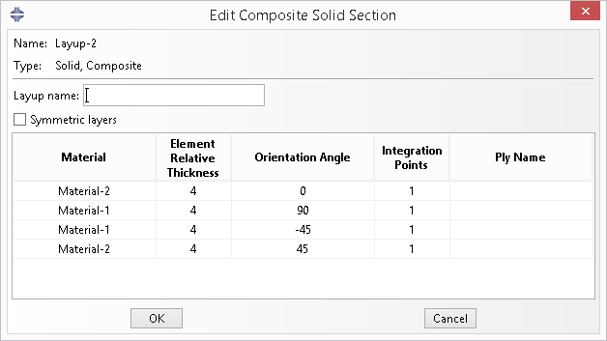

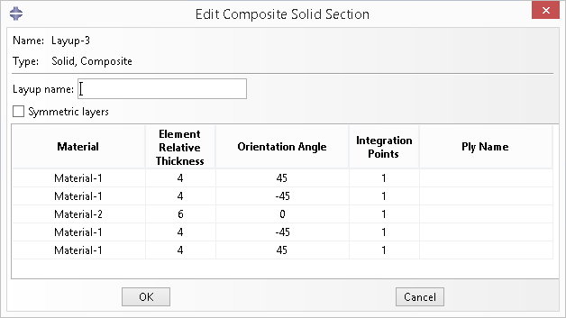

Note here that the thickness of each layer should be actual thickness instead of relative thickness.
Step 4: Draw the general shape
According to the coordinates convention in SwiftComp, the X-axis is along the beam reference line and the cross-section is in the Y-Z plane. Thus we need to first set our workplane to Y-Z plane. In the SwiftComp Toolset, click the icon button , set the ‘New Part Name’ and select ‘2D’ as the ‘SG Dimension’. Click ‘OK’.


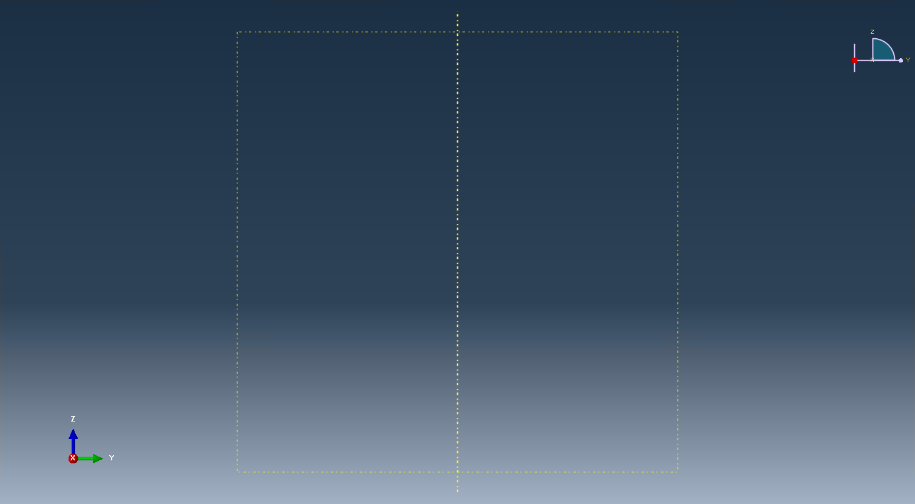

In the toolbox of the Part module, click ‘Create Shell: Planar’ , following the prompt, select the datum plane and the datum axis. Sketch the shape shown below, using commands , , , , with dimensions marked in the figure.
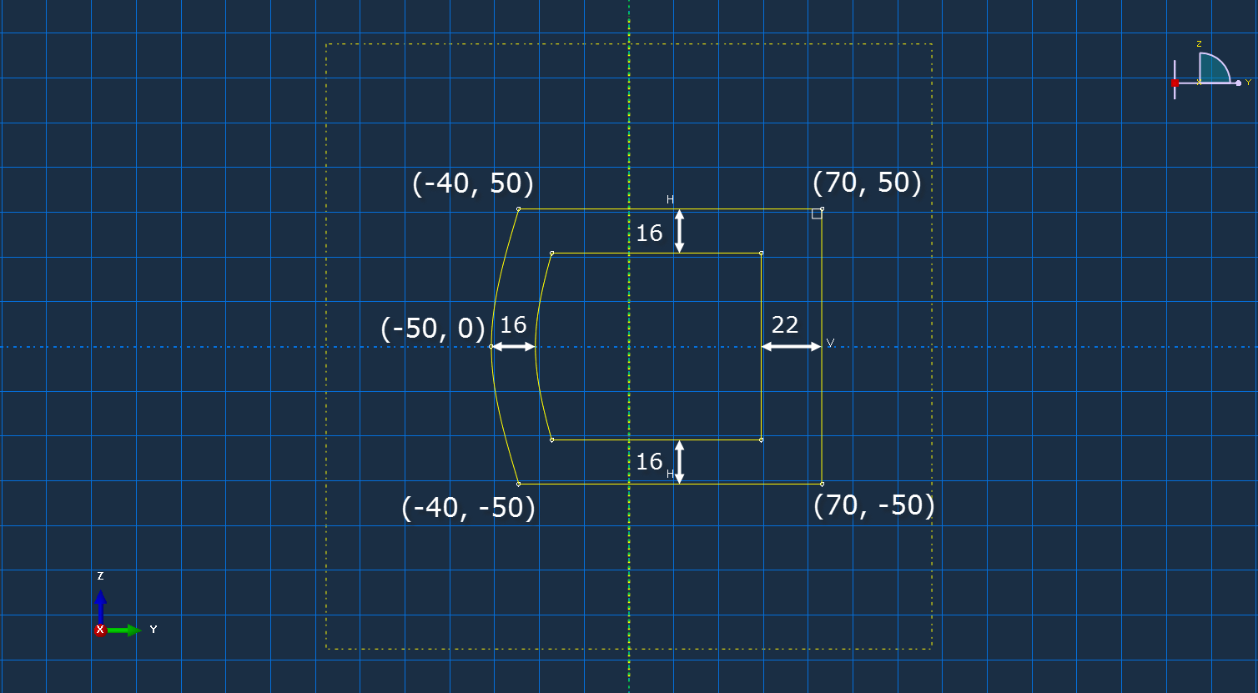

Click ‘Done’, then the part will be generated.
Next we need to divide this part into four segments. Click ‘Partition Face: Sketch’ and select a vertical edge on the right. Then sketch the partition and click ‘Done’.
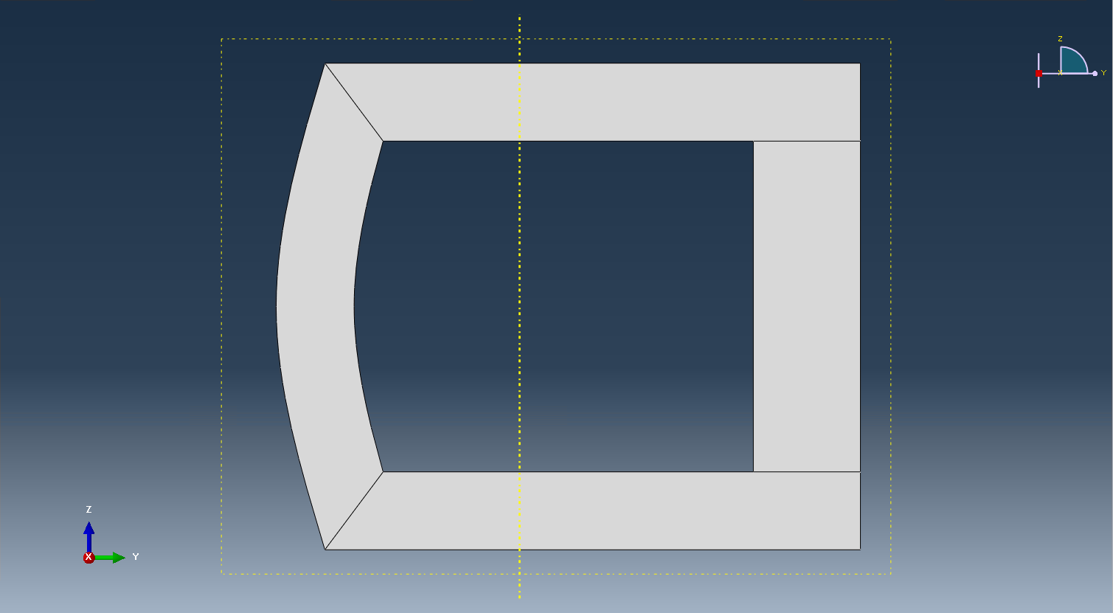

Step 5: Assign layups
First we will assign the layup for the segment on the top. Click ‘Assign Layups’ in the SwiftComp toolset. Pick the area 1, pick the baseline 2 and select section ‘Layup-1’. Click ‘OK’.
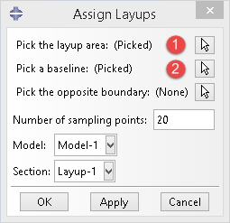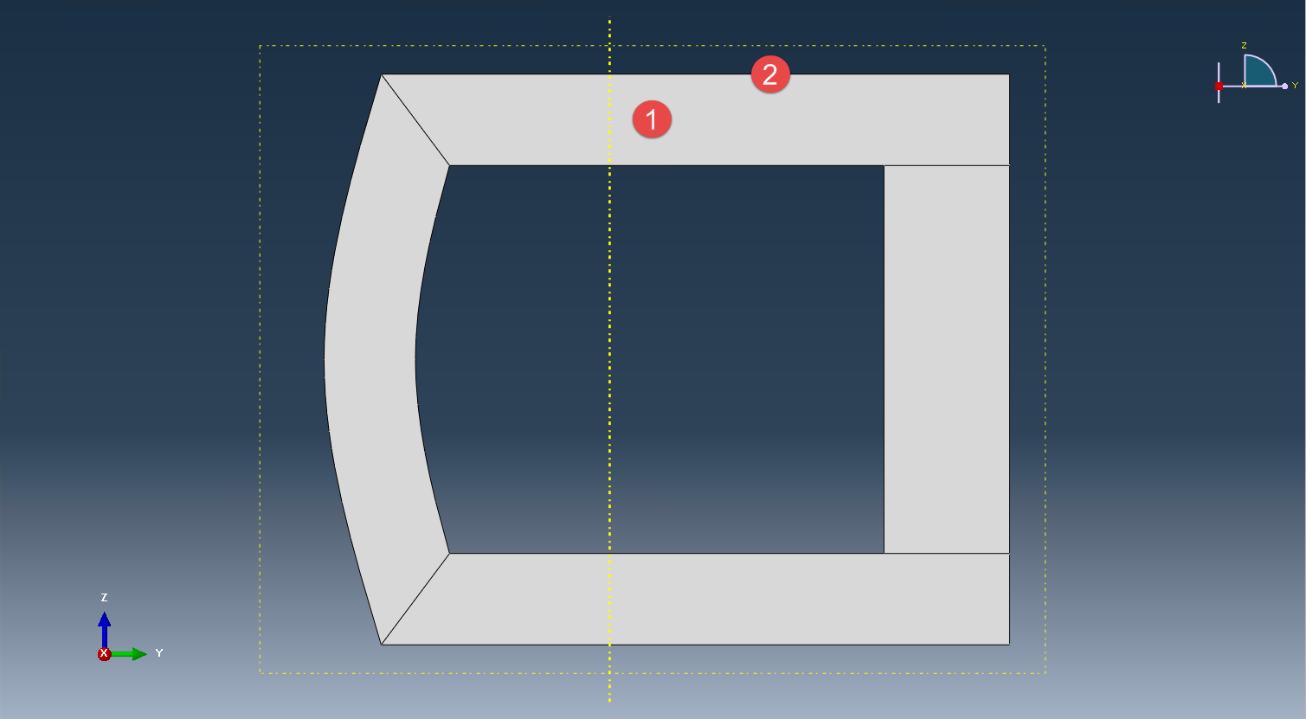

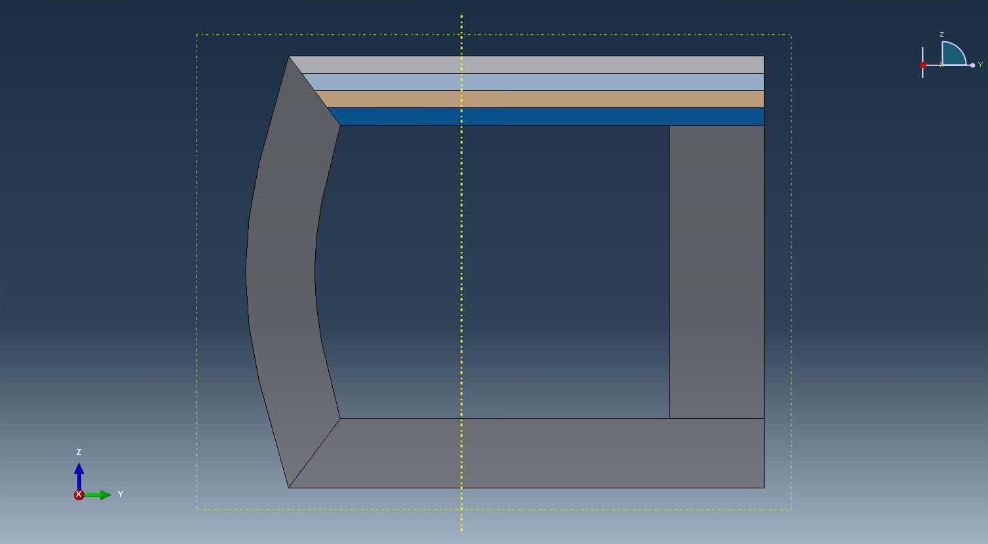

Next, assign the layup for the segment on the left. Pick the area 1, baseline 2, opposite boundary 3, give 20 sampling points and select section ‘Layup-1’. Click ‘OK’.
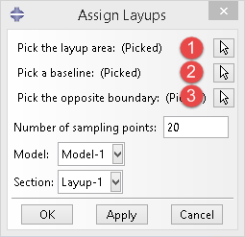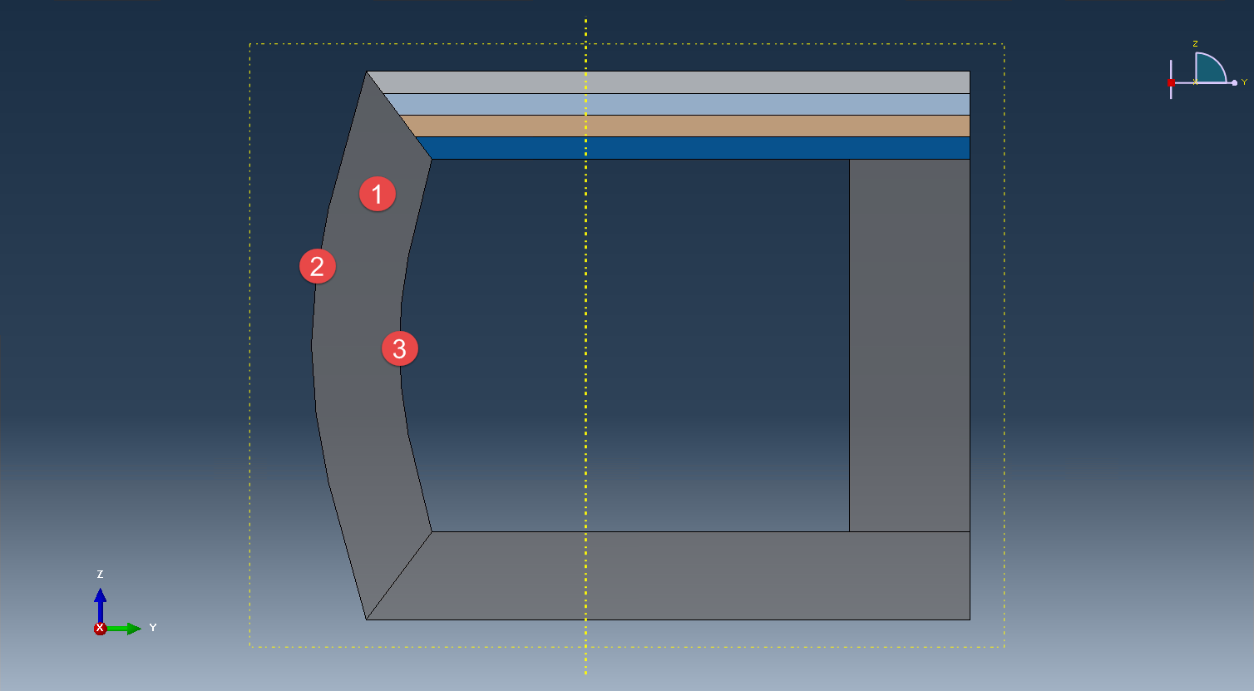

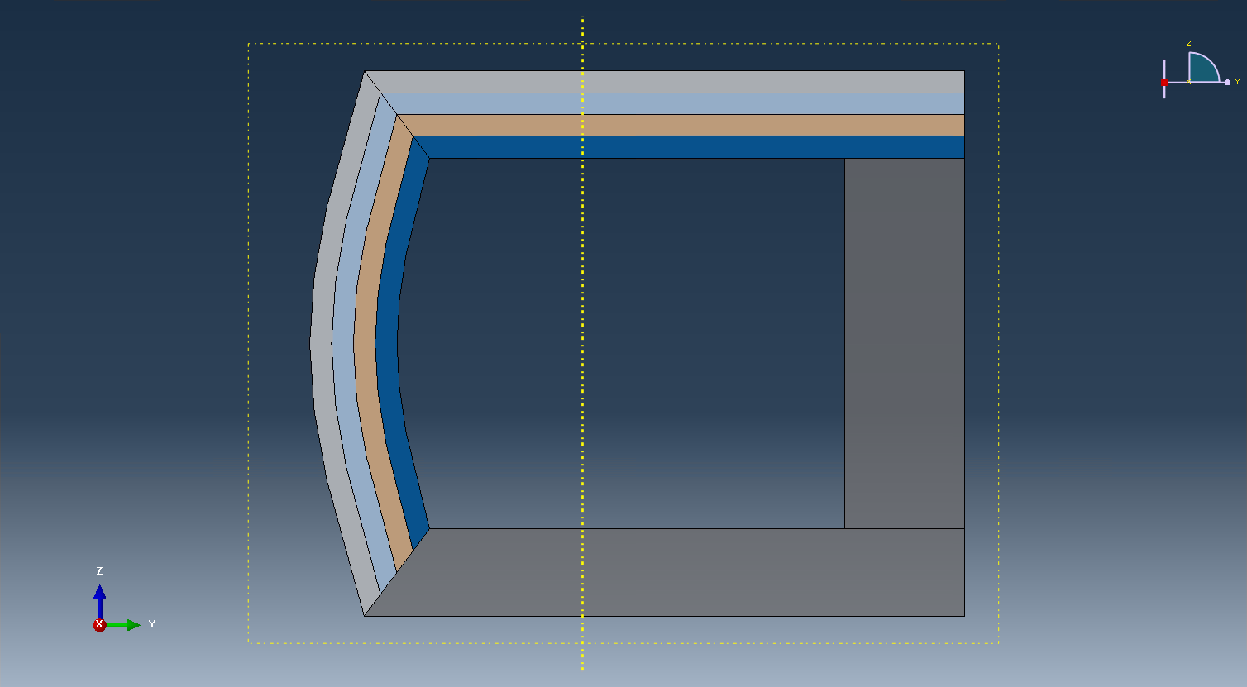

We can do the same for the rest two segments, except that we use ‘Layup-3’ for the right segment.
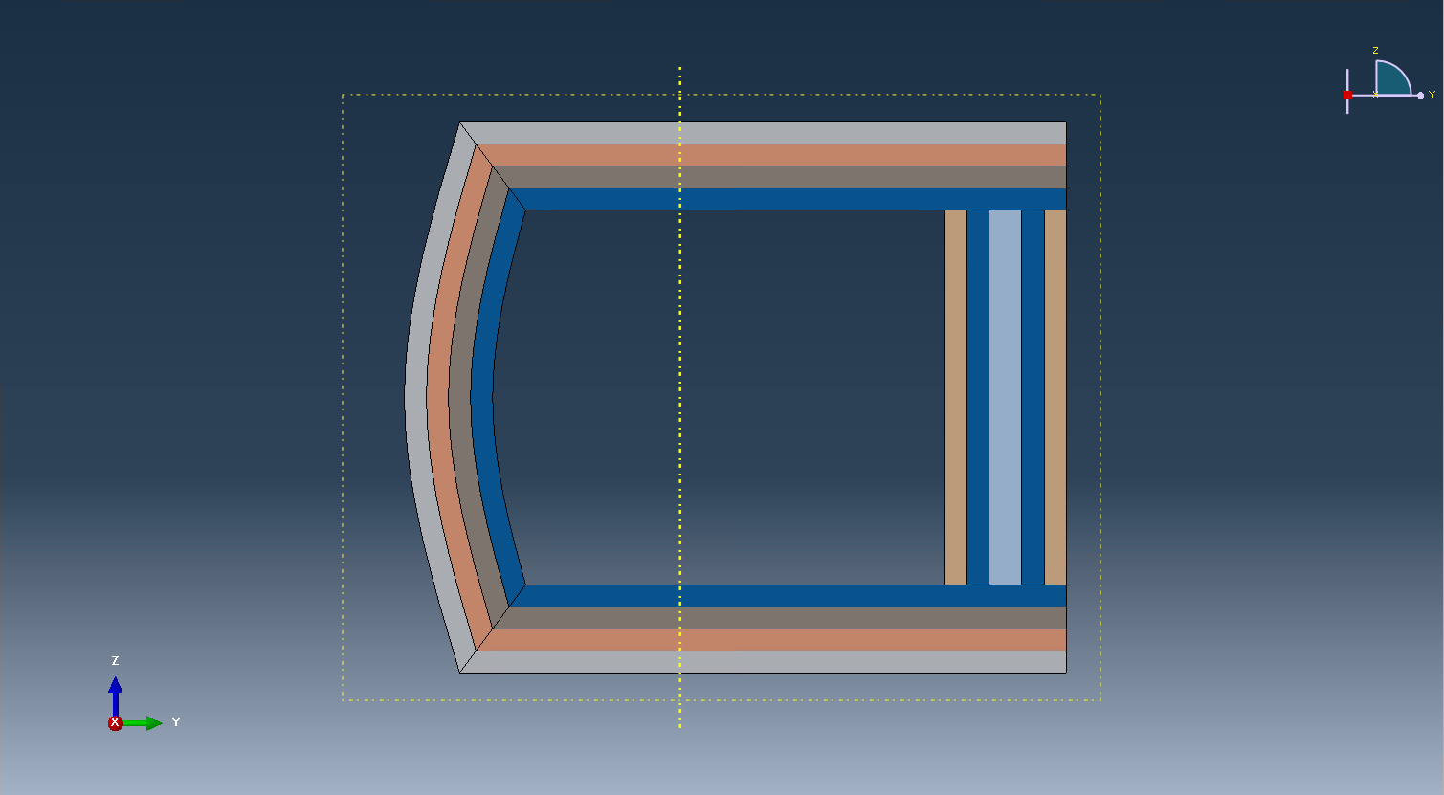

User may notice that the color for some layers changed after assigning the layup for the right segment. This is because we have some new sections created in ‘Layup-3’ and the order of the section list changed, so that the color map also changed. But no need to worry here, since the section assignment are still right, the only difference is the color.
Step 6: Delete layups
If users find that some layup is assigned mistakenly, it can be deleted and re-assigned. For instance, we want to re-assign the layup for the left segment. Click ‘Erase Layups’ . In the dialog box pick the same baseline used for assigning the layup. Click ‘OK’.
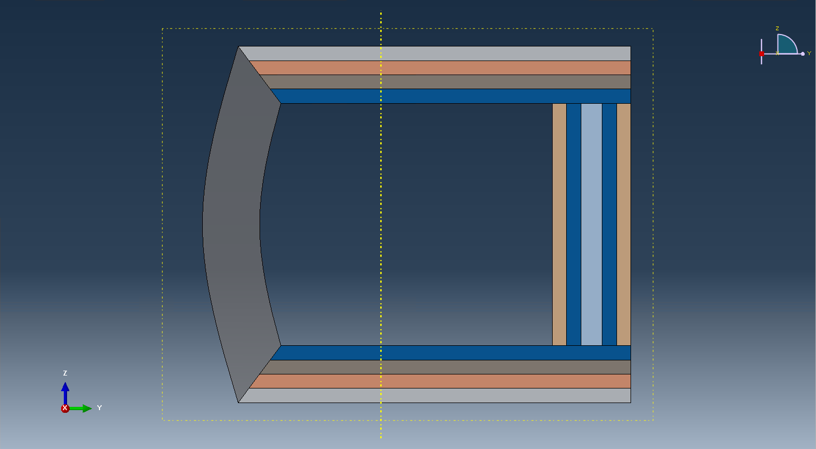

Once done, user can assign a new layup for the empty segment. Here we assign the ‘Layup-2’.
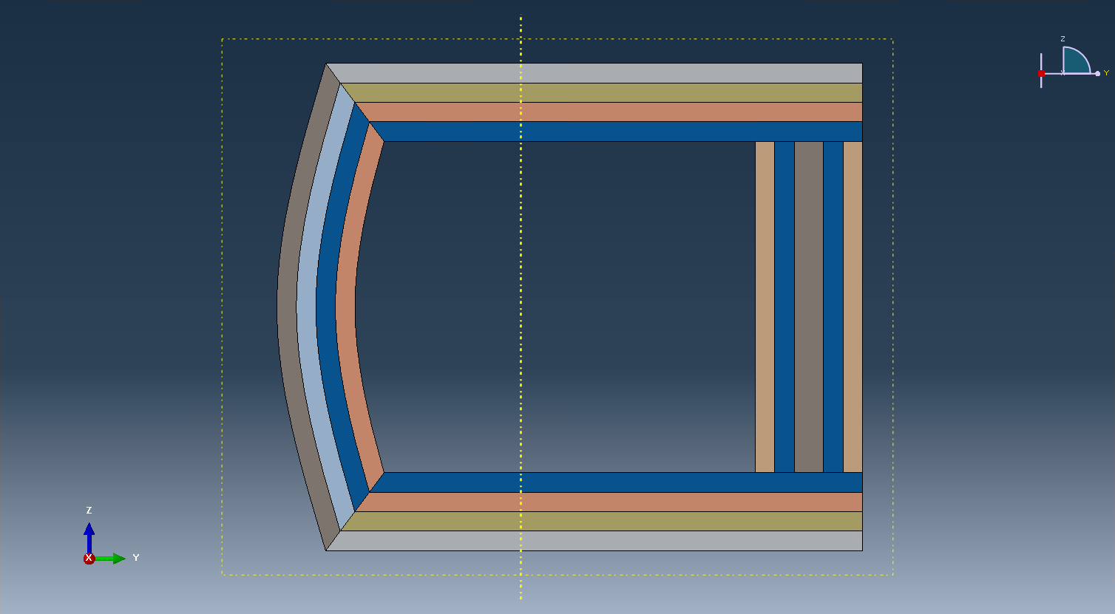

Step 7: Assign local coordinates
Module > Property > Assign Material Orientation . Note: for a shell part in Abaqus, we can only have axis 1 and 2 in the cross-section plane. Thus we will make axis 1 and 2 as the local y2 and y3 axis in SwiftComp convention respectively. Here we will keep axis 2 (y3) perpendicular to the outmost edges and pointing to the outside. User can also let axis 2 point inward, as long as the local orientation keeps consistency with the global coordinate and fiber orientations defined by users. Following the prompt, we first select the top segement to be assigned a local material orientation, and click ‘Done’. Then in the prompt area, click ‘Use Default Orientation or Other Method’ button. In the ‘Edit Material Orientation’ dialog box, select ‘Discrete’ as the Orientation Definition. Then click , open the ‘Edit Discrete Orientation’ dialog box. In the Normal axis definition choose Vector (i,j,k), and set the vector (1.0, 0.0, 0.0). For Primary Axis, choose 1 as the Primary axis direction and Edges as the Primary axis definition. Click to select the light blue edge shown in the figure below, then click ‘Done’. Use Flip Direction to make the axis pointing to the right if necessary. Click ‘Continue...’ then ‘OK’ to finish this assignment. Same procedure for the rest three segments. Some steps may not be exactly the same. The only requirement is to make sure that the asix 2 pointing outwards.
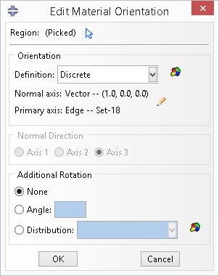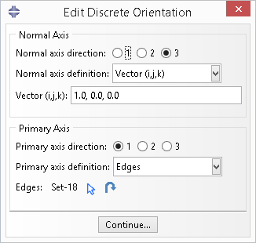

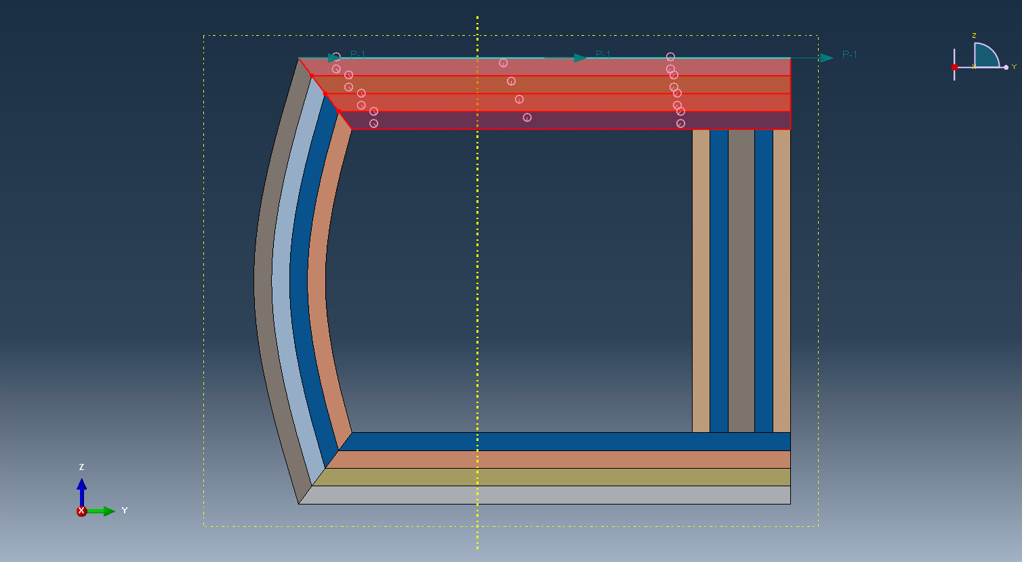

Once done, the local orientations should look like the same as the figure shown below.
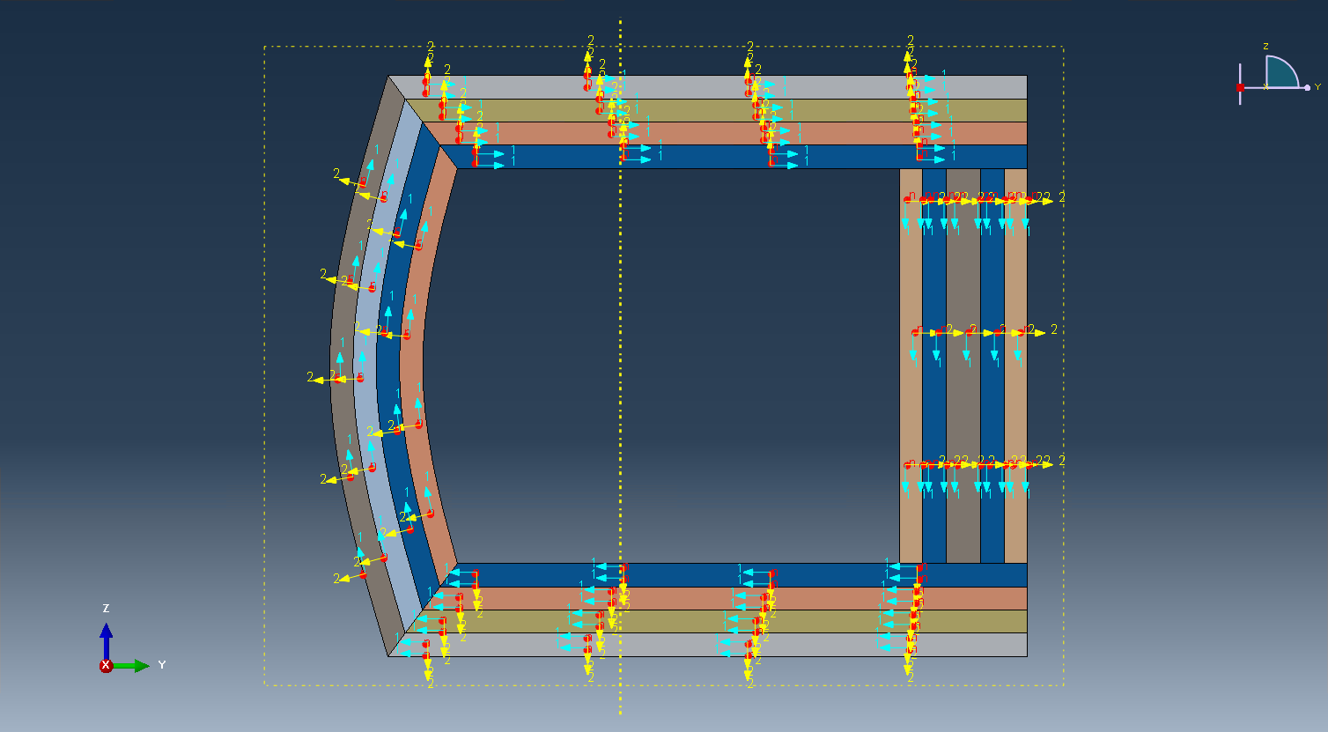

Step 8: Create assembly
Module > Assembly > Create Instance . In the ‘Create Instance’ dialog box, select ‘Part-1’, then click ‘OK’.
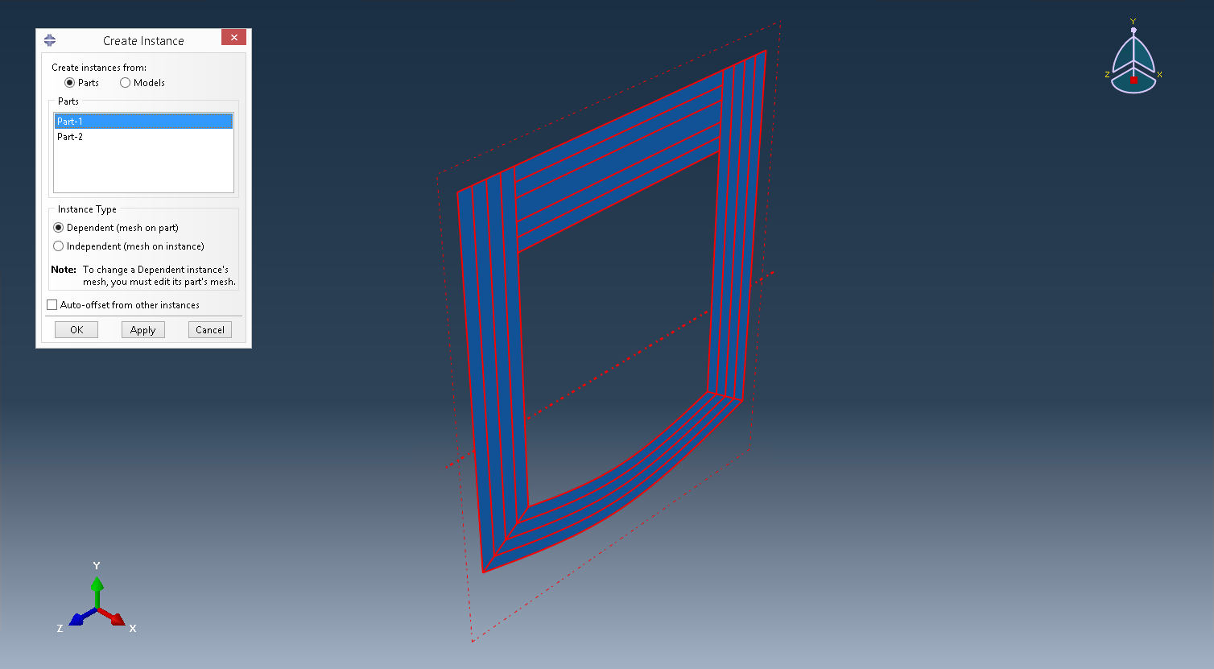

Step 9: Mesh
First choose ‘Part’ as the Object. Then click Module > Mesh > Seed Part . In the ‘Global Seeds’ dialog box, set Approximate global size to 1, then click ‘OK’, and click ‘Done’ in the prompt area.
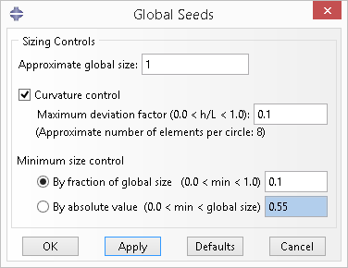

Click ‘Mesh Part’ , then click ‘Yes’ in the prompt area.
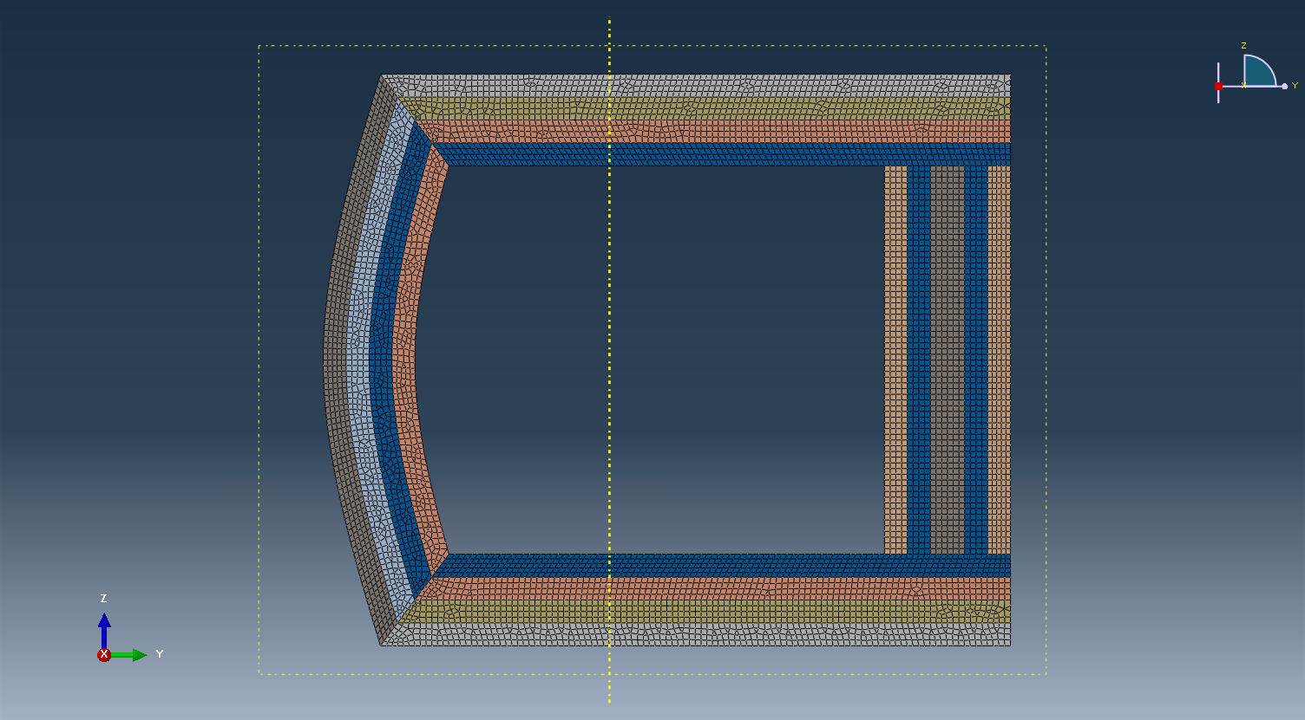

Step 10: Write Abaqus input file
Module > Job > Create Job . In the ‘Create Job’ dialog box, set Name to ‘Job-1’ and click ‘Continue...’, and click ‘OK’ in the ‘Edit Job’ dialog box. In the model tree, right click ‘Job-1’, click Write Input, then an Abaqus input file ‘Job-1.inp’ is created.

Step 11: Homogenization
Click ‘Homogenization’ button in the SwiftComp toolset. In the dialog box, change the ‘Model source’ to ‘Input file’. For ‘Abaqus input file’, select the abaqus input we just created, ‘Job-1.inp’. Then click ‘OK’. Note: since we assigned discrete local coordinates to the cross-section, those information for each element can only be found in the Abaqus input file. Thus user can only choose ‘Input file’ as the ‘Model source’ to do the homogenization.
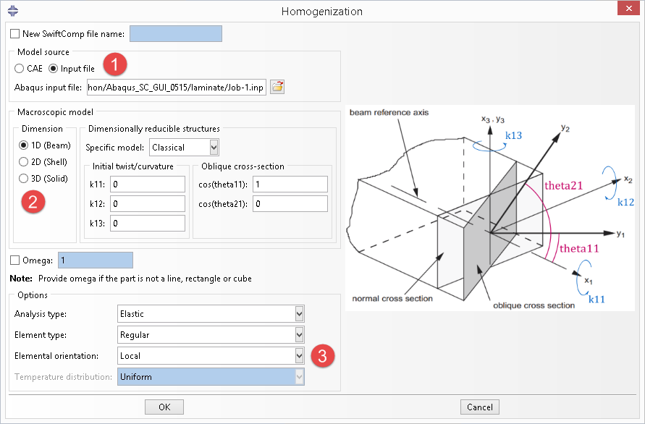

After a certain time, depending on the model, SwiftComp will finish computing the cross-sectional properties and show the results in the notepad. If everything is fine, close the notepad and the process will end.
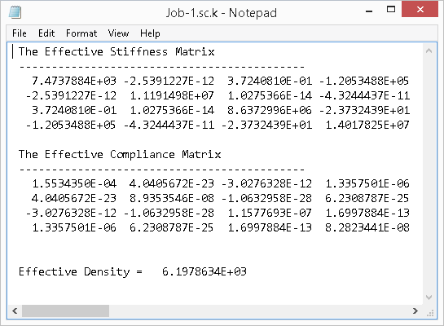

If error messages pop out, or an empty notepad file appears, please refer to the command line window for more information.

3.5 Cross-Section with Airfoil Shape

3.5.1 General
Cross-sections with airfoil shape usually contain several parts, like surfaces, webs and fillings, and the surface part has several segments and each segment has dozens or hundreds of layers, which makes it very difficult to build the model by hand as what we have shown in the previous section. The SwiftComp GUI will help user to draw the cross-section and prepare the SwiftComp input file automatically from airfoil data. Thus the main topic of this section is the preparation of data files. Once those files are ready, the whole process will be done by one click. A sample set of files are also given in the folder airfoil which the users can use as template to adapt for their own cross-sections.

3.5.2 Input data files
User needs to provide four files: control file, shape file, material file and layup file, which are all XML files. All files should be placed in the same folder. Now we will describe each file in details.
- Control file
This is the main input that will be used in the SwiftComp GUI.
<project type="airfoil">
<shapes>shape_filename</shapes>
<materials>material_filename</materials>
<layups>layup_filename</layups>
<pitch_axis_yz>0.4750054 0.0</pitch_axis_yz>
<twisted_angle>0.0</twisted_angle>
<chord_length>1.89999874</chord_length>
<flip>No</flip>
</project>
‘<project></project>’ is the root element, which has an attribute ‘type=“airfoil”’. Since the ‘Read File’ function mainly deals with cross-sections with airfoil shape, this arribute can be omitted for the current version. There are seven sub-elements below ‘<project></project>’. The first three sub-elements indicate the names of the other three data files, with file extensions “.xml” being appended or omitted. The next three lines tell the general shape parameter for the airfoil. Element ‘<pitch_axis_yz></pitch_axis_yz>’ indicates the normalized location of the pitch axis in the Y-Z plane, which is the cross-section plane. The two numbers are separated by spaces. Element ‘<twisted_angle></twisted_angle>’ contains the angle in degree between the actual chord line and the horizontal line. In the figure below, the ‘angle of attack’ is what we mean by ‘twisted angle’ here. Element ‘<chord_length></chord_length>’ stores the actual length of the chord line. The last element ‘<flip></flip>’ is used to indicate whether user want to switch the orientation of the airfoil. By default, the leading edge is on the left. See the figure below for a sketch of a typical cross-section of airfoil shape.
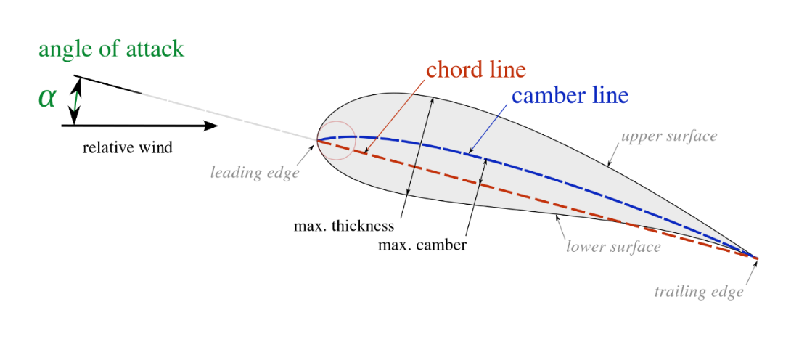
- Shape file
This file stores the shape data of the surfaces, webs and fillings, including the geometry information like coordinates of points and the segment division information like the dividing point number and the layup id that will be assigned to this segment. The structure is shown below.
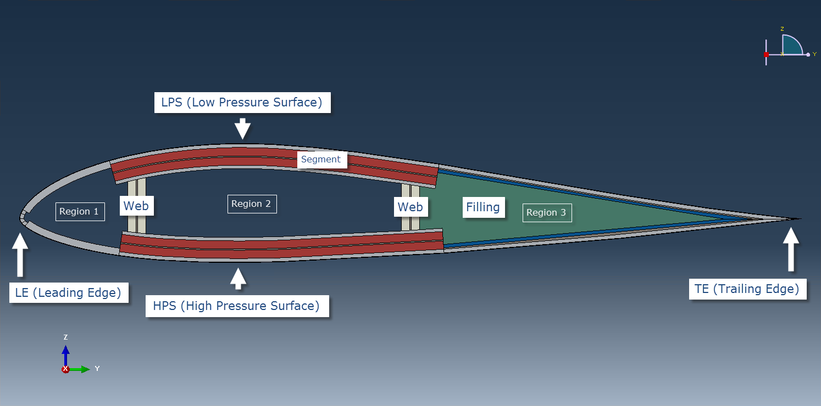
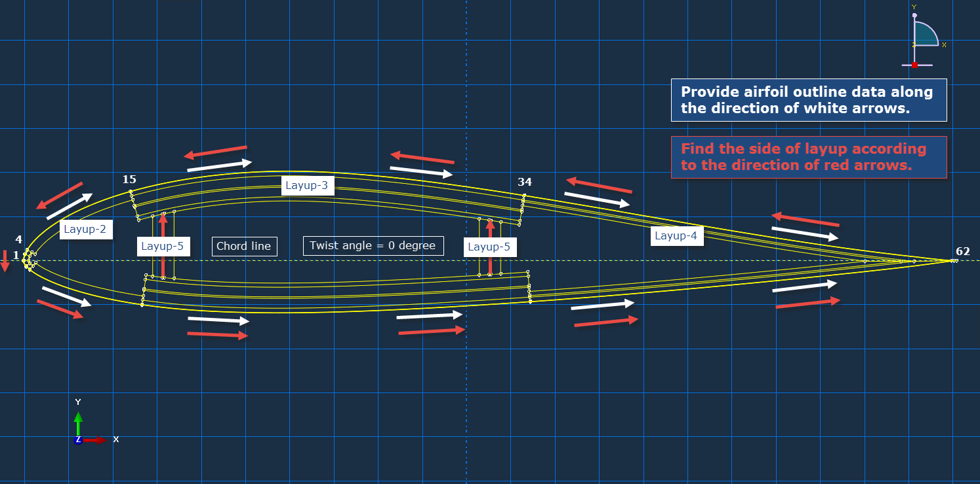

<?xml version = "1.0" encoding = "UTF-8"?>
<assembly type = "airfoil">
<part structure = "surface">
<baseline type = "spline" format = "lednicer">
<lps>
0 0
0.00035937 0.0029595
0.00162747 0.00696192
... ...
9.97E-01 1.33E-04
1.00E+00 0.00E+00
</lps>
<hps>
0 0
0.00062671 -0.00294872
0.0030035 -0.00629665
... ...
0.9970425 -0.00036119
1 0
</hps>
</baseline>
<layup side = "left">
<lps>
1 3 1
...
</lps>
<hps>
1 3 1
...
</hps>
</layup>
</part>
<part structure = "web">
<baseline>
<y_z_angle>0.15 0.0 90.0</y_z_angle>
...
</baseline>
<layup side = "both">
5
...
</layup>
</part>
<part structure = "filling">
<region material = "6">3</region>
...
</part>
</assembly>
There is a root element ‘<assembly></assembly>’, whose attribute ‘type’ can be omitted for the current version. The child element is ‘<part></part>’ and the attribute ‘structure’ for each part tells what the part is, surface, web or filling. For laminate-like part, surface and web, there are two sub-elements, ‘<baseline></baseline>’ and ‘<layup></layup>’.
The ‘baseline’ element of the ‘surface’ part contains two sub-elements, ‘<lps></lps>’ and ‘<hps></hps>’, which store the raw data of the airfoil low pressure surface and high pressure surface, respectively. Two attributes, ‘type’ and ‘format’ may be used in the future version and can be omitted here. The arrangement of data for both ‘lps’ and ‘hps’ is from (0, 0) to (1, 0), which is from the leading edge to the trailing edge. The ‘baseline’ element for the ‘web’ part contains any number of sub-elements ‘<y_z_angle></y_z_angle>’, each of whom stands for a web. Here a web is represented by a straight line. The first two numbers are the normalized position of the baseline on the chord line and the last number is the angle in degree measured from the chord line segment near the leading edge to the upper part of the web baseline.

The ‘layup’ element has an attribute ‘side’, which can have the value ‘left’, ‘right’ or ‘both’. The ‘side’ is defined according to the direction of the surface baseline, which starts from the trailing edge, goes along the low pressure surface baseline to the leading edge and back to the trailing edge along high pressure surface baseline. So basically, if the ‘side’ is ‘left’, then the plies are laid towards the inside of the airfoil. Thus if the surface baseline is the outmost profile and the leading edge is on the left, then the ‘side’ should be ‘left’. The value ‘both’ means doing the layup on both sides of the baseline, but will not double the layup. Or more precisely, this means that the baseline is at the middle of the layup. For the current version, this case can only handle symmetric layup. Otherwise, user needs to translate the baseline to one side and change some values in the file accordingly. The ‘layup’ element for the ‘surface’ part contains two sub-elements ‘<lps></lps>’ and ‘<hps></hps>’. In each of them, there are several lines of data and each line represents a segment and has three numbers. The first two numbers are the starting and ending points for the segment and the last one is the layup id that will be defined in the layup file. The first number of the first line must be 1 and the second number of the last line has to be the total number of points for low pressure surface or high pressure surface. The ‘layup’ element for ‘web’ part is much simpler. Each line only contains the layup id for the web.

For the ‘filling’ part, such as foam, has only one type of sub-element, ‘<region></region>’. The number stored between the two tags is region id, which is defined as follows. If there are two webs, then the inner space of the airfoil is divided into three regions. Starting from the leading edge, those regions are labeled as ‘1’, ‘2’ and ‘3’. The attribute ‘material’ stores the material id, which is defined in the material file. Here we make the assumption that the materials used for the fillings are homogeneous, could not generally anisotropic, with material properties given in the global coordinates.
- Material file
Please see section 3.3.2
- Layup file
Please see section 3.3.2

3.5.3 Create cross-section model in Abaqus from input files
Step 1: Set working directory
The working directory should contain those data files.
Step 2: Read input files
Click ‘Read File’ , set a project name and select the control file. Click ‘OK’.
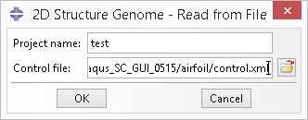

Once done, user should see a meshed airfoil cross-section with different colors representing different layer types, as shown in the figure below.
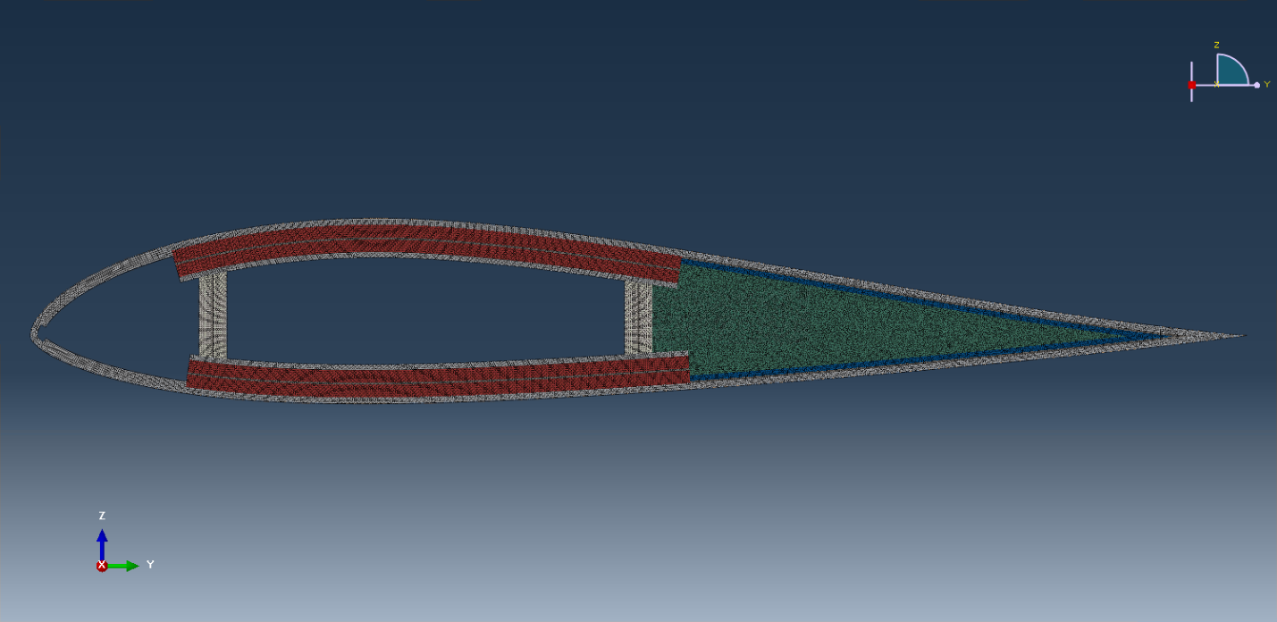

Step 3: Make some changes (optional)
At this stage, user can change material properties or meshes. Following these modifications, user need to re-write the Abaqus input file from the job.
User can also do the creation in command line without entering Abaqus/CAE. First, user needs to enter the directory where the script ‘drawCS.py’ is located. Then type:
abaqus cae noGui=drawCS.py -- project_name control_file
where ‘control_file’ is the complete file name including path and extension. Press ‘Enter’. Once done, all those related files can be found in the same place where the control file is.

3.5.4 Homogenization
Click ‘Homogenization’ button in the SwiftComp toolset. In the dialog box, change the three items shown as in the figure below. For ‘Abaqus input file’, select the abaqus input we just created, ‘project_name.inp’. Then click ‘OK’.
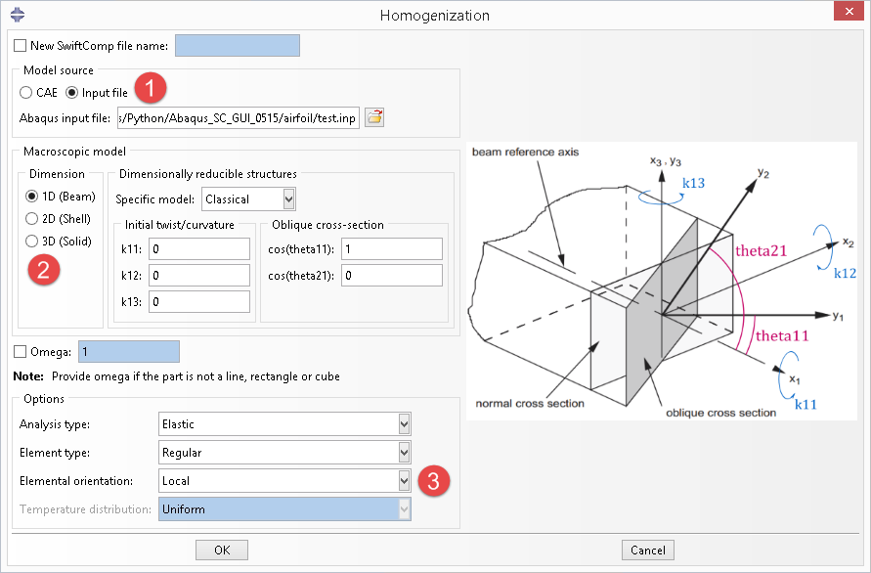

After a certain time, depending on the model, SwiftComp will finish computing the cross-sectional properties and show the results in the notepad. If everything is fine, close the notepad and the process will end.
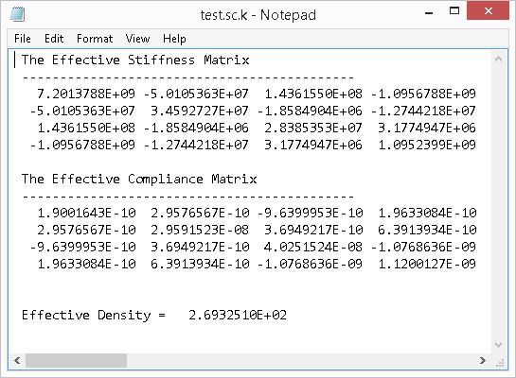
If error messages pop out, or an empty notepad appears, please refer to the command line window for more information.

IMPORT HOMOGENIZED PROPERTIES TO MACRO MODEL ANALYSIS

The homogenized properties obtained from homogenization can be imported into a new model with the name of the sg model. Click the button as shown in the Fig. 4.0-1, a window shown in Fig.4.0-2 will pop out. There are 2 methods to import the homogenized properties. If the sg model is existed, the user can choose the sg model name (sg_name); if there is only SwiftComp analysis file (.sc.k) available, the user can choose the file and also specify the Analysis type and Macroscopic model dimension. Click OK and the homogenized properties will be imported.
The examples of Section 2.1 Laminate (1D SG) are used to show how to importe homogenized properties in this Section.
If the macro model is plate/shell, general plate stiffness will be imported to sections in the Property module (Fig. 4.0-2, Fig. 4.0-3).
If the macro model is 3D solid, homogenized anisotropic material properties will be imported into materials in the Property module. If the homogenized material properties is orthotropic (when expressed in the global coordinate system) and can be expressed using Engineering Constants, a material defined using Engneering Constants will also be defined in materials (Fig. 4.0-4).
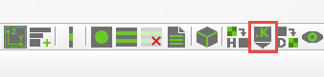
Figure 4.0-1 Import the homogenize properties in to Abaqus CAE

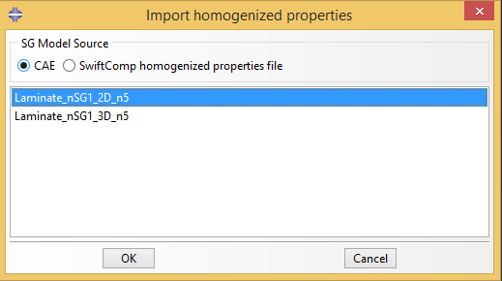
(a) Import from sg model information
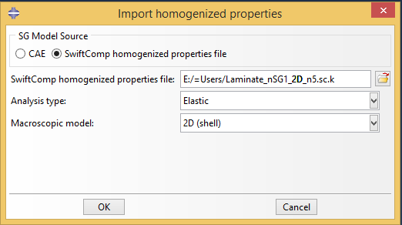
(b) Import from SwiftComp homogenization result file (*.sc.k)
Figure 4.0-2 Import the homogenize general stiffness section properties of shell model into Abaqus

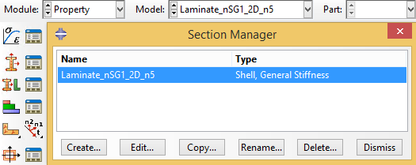
Figure 4.0-3 Imported homogenize general stiffness section properties of shell model

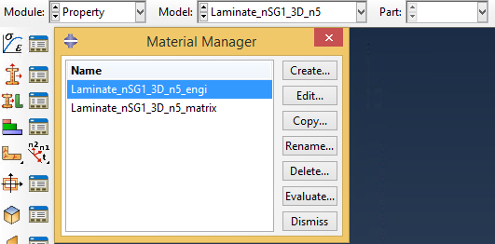
Figure 4.0-4 Imported homogenize material properties of solid model

